The Velvet Underground – Sweet Jane (1970)
Intro BPM 136 : [ D A Bm G / A | D A Bm / A G / A ] x 2
D D / A G Bm / A
BPM 108
Strum BhbHbHBh
Standin' on the corner,
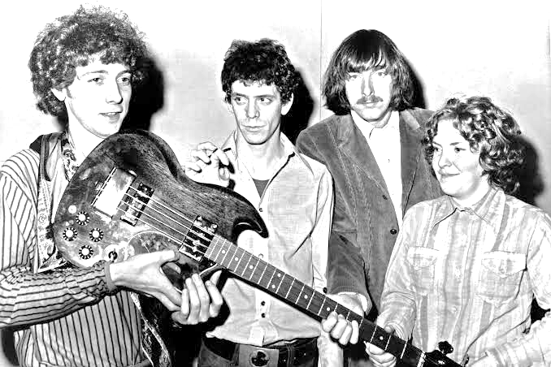
D D / A G Bm / A
Suitcase in my hand
D D / A G Bm / A
Jack is in his corset, Jane is in her vest
D D / A G Bm / A
And me, I'm in a rock 'n' roll band Huh
D D / A G Bm / A
Riding in a Stutz Bear Cat, Jim
D D / A G Bm / A
Ya know, those were different times
D D / A G Bm / A D
Oh, all the poets, they studied rules of verse And those ladies
D / A G Bm / A
they rolled their eyes
D G
[Chorus] Sweet Jane, woah x 3 ….Let me tell ya somethin'

D D / A G Bm / A
Jack, he is a banker
D D / A G Bm / A
And Jane, she is a clerk just watch me now
D D / A G Bm / A
And both of them save their monies
D D / A G Bm / A
Hah, and when, when they come home from work...
D D / A G Bm / A
Ooh, sittin' down by the fire, oh
D D / A G Bm / A D D / A
The radio does play the classical music there, Jim
G Bm / A D
The March of the Wooden Soldiers All you protest kids,
D / A G Bm / A
you can hear Jack say Get ready
- Chorus
D D / A G Bm / A
Some people, they like to go out dancin'
D D / A G Bm / A
And other peoples, they have to work, just watch me now
D D / A G Bm / A
And there's even some evil mothers
D D / A G Bm / A
Well, they're gonna tell you that everything is just dirt
D D / A G Bm / A
You know that women never really faint
D D / A G Bm / A
And that villains always blink their eyes, ooh
D D / A G Bm / A
And that, ya know, children are the only ones who blush
D D / A G Bm / A
And that life is just to die
Bridge : D % G Bm /A
But anyone who ever had a heart
Oh, they wouldn't turn around and break it
And anyone who ever played a part
Oh, they wouldn't turn around and hate it
- Chorus
[Bridge] D C#m
Heavenly wine and roses
G# A B x 2
Seem to whisper to her when he smiles
(1er tour : when he smiles, 2ème tour : when she smiles)

E B D A
La, la, la, la-la-la La, la, la, la-la-la x 2

[Outro] D G
Sweet Jane Sweet Jane x 3

