KOKOMO - The Beach Boys ‧ (1988) Tonalité : C BPM116 strum Calypso
C % F %
INTRO :
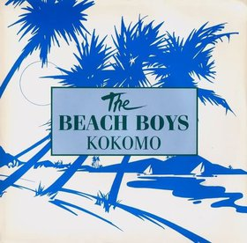
Aruba, Jamaica, ooh, I wanna take ya Bermuda, Bahama, come on, pretty mama
C % F x . . .
Key Largo, Montego, baby, why don't we go? Jamaica
C % Gm7 F
Off the Florida Keys there's a place called Kokomo
Fm C D7 G7
That's where you wanna go to get away from it all
C C7M Gm7 F
Bodies in the sand Tropical drink melting in your hand
Fm C D7 G7
We'll be falling in love To the rhythm of a steel drum band Down in Kokomo (Aruba…)

C C F F
CHORUS :
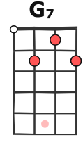 | 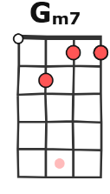
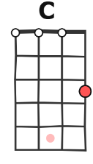 | 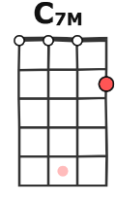
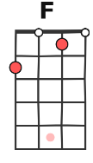 | 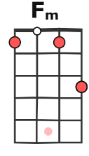
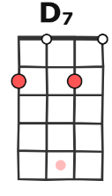 | 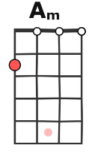
Aruba, Jamaica, ooh, I wanna take you to Bermuda, Bahama, come on, pretty mama
C C F
Key Largo, Montego, Ooh, why don't we go down to Kokomo
Fm C Am D7
We'll get there fast, and then we'll take it slow That's where we wanna go
G7
Way down in Kokomo … (Mar..)
C C
Mar-tinique, that Montserrat mystique
C C7M Gm7 F
We'll put out to sea And we'll perfect our chemistry
Fm C D7 G7
By and by, we'll defy A little bit of gravity
C C7M Gm7 F
Afternoon delight Cocktails and moonlit nights
Fm C D G7
That dreamy look in your eye give me a tro-pi-cal contact high
C
Way down in Kokomo (Aruba…)
. CHORUS
C
Port au Prince, I wanna catch a glimpse
SOLO :
C C7M Gm7 F Fm C D G7
C C7M Gm7 F

Everybody knows A little place like Kokomo
Fm C D G7
Now if you wanna go and get away from it all Go down to Kokomo
CHORUS x 2 Fin sur : Way down in Kokomo …

