No milk today Herman’s Hermits 1966 Bpm: 132 Tonalité originale
Rythme : BhBhBhBh
Couplet 1

Am C E / Am E / Am
No milk today my love has gone away The bottle stands forlorn a symbol of the dawn
Am C E / Am E / Am
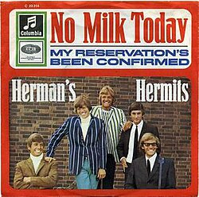
No milk today it seems a common sight But people passing by don't know the reason why
A G
How could they know just what this message means?
D E / A
The end of my hopes the end of all my dreams
A G
How could they know the palace there had been
D E / A
Behind the door where my love reigned as queen ?
Am C E / Am E / Am Am Am
No milk today it wasn't always so The company was gay we'd turn night into day
A / E F#m / E A / E D…
But all that's left is a place dark and lonely A terraced house in a mean street back of town
A / E F#m / E D… / E…
Becomes a shrine when I think of you only Just two up two down
Couplet 2
Am C E / Am E / Am
No milk today it wasn't always so The company was gay we'd turn night into day
Am C E / Am E / Am
As music played the faster did we dance We felt it both at once the start of our romance
A G
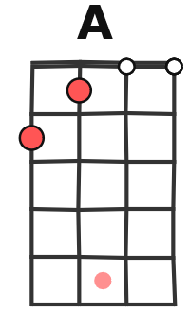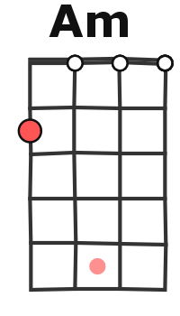
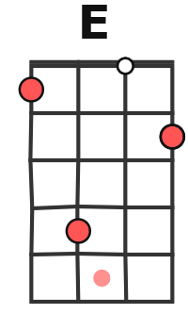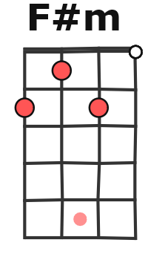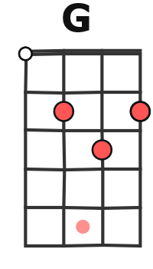
How could they know just what this message means?
D E / A
The end of my hopes the end of all my dreams
A G
How could they know the palace there had been
D E / A
Behind the door where my love reigned as queen ?
Am C E / Am E / Am Am Am
No milk today my love has gone away The bottle stands for love a symbol of the dawn
A / E F#m / E A / E D…
But all that's left is a place dark and lonely A terraced house in a mean street back of town
A / E F#m / E D… / E…
G / V1
Becomes a shrine when I think of you only Just two up two down

Couplet 1

A / E F#m / E A / E D… (x3)
But all that's left is a place dark and lonely A terraced house in a mean street back of town

