No milk today Herman’s Hermits 1966 Bpm: 132 Tonalité originale : Am
Rythme : BhBhBhBh
Couplet 1

Gm Bb D / Gm D / Gm
No milk today my love has gone away The bottle stands forlorn a symbol of the dawn
Gm Bb D / Gm D / Gm
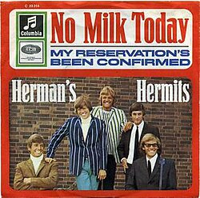
No milk today it seems a common sight But people passing by don't know the reason why
G F
How could they know just what this message means?
C D / G
The end of my hopes the end of all my dreams
G F
How could they know the palace there had been
C D / G
Behind the door where my love reigned as queen ?
Gm Bb D / Gm D / Gm Gm Gm
No milk today it wasn't always so The company was gay we'd turn night into day
G / D Em / D G / D C…
But all that's left is a place dark and lonely A terraced house in a mean street back of town
G / D Em / D C… / D…
Becomes a shrine when I think of you only Just two up two down
Couplet 2
Gm Bb D / Gm D / Gm
No milk today it wasn't always so The company was gay we'd turn night into day
Gm Bb D / Gm D / Gm
As music played the faster did we dance We felt it both at once the start of our romance
G F
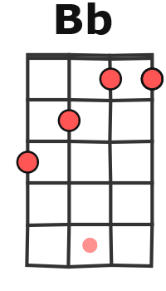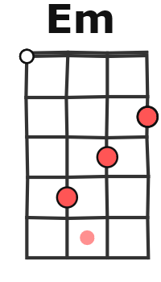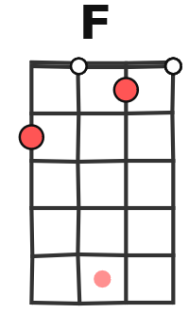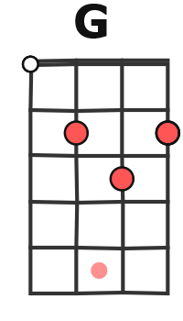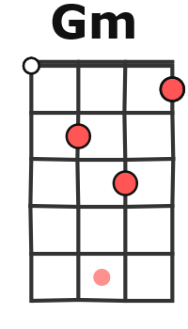
How could they know just what this message means?
C D / G
The end of my hopes the end of all my dreams
G F
How could they know the palace there had been
C D / G
Behind the door where my love reigned as queen ?
Gm Bb D / Gm D / Gm Gm Gm
No milk today my love has gone away The bottle stands for love a symbol of the dawn
G / D Em / D G / D C…
But all that's left is a place dark and lonely A terraced house in a mean street back of town
G / D Em / D C… / D…
G / V1
Becomes a shrine when I think of you only Just two up two down

Couplet 1

G / D Em / D G / D C… (x3)
But all that's left is a place dark and lonely A terraced house in a mean street back of town

