Girls and Boys Blur 1994 Tonalité originale Bpm : 120
Intro x2
Gm % C7 %  A|--10-10-10-10-|-10-10-10-10-|-10-10-10-10-|-10-10-10-10-|  E|-------------------|-------------------|------------------|------------------|  C|-7---7---7---7--|-7---7---7---7--|-7---7---7--7---|-7--7--7--7----|  F % Eb Eb / F# - F  A|-- 8---8---8---8-|--8---8---8---8-|--6--6--6--6--|--6---6---9---8-|  E|--------------------|------------------ |-----------------|------------------|  C|--5---5---5---5--|-5---5---5---5--|-3--3--3--3---|-3---3---6---5--| |   BhBh-hBh -hBh-hB  Gm %

Gm % C7 %  Street ‘s like a jungle So call the police  F % Eb Eb / F# - F  Following the herd down to greece On holiday  Gm % C7 %  Love in the 90´s Is paranoid  F % Eb Eb / F# - F  On sunny beaches Take your chan----ces looking for  Refrain  Gm %  Girls who are boys Who like boys to be girls Who do  C7 %  boys like they´re girls who do girls like they´re boys  F % Eb Eb / F# -F  Always should be some-one you really lo-------ve  Gm % C7 %  Avoiding all work cause there´s none available  F % Eb Eb / F# - F  Like battery thinkers Count their thoughts on 1 2 3 4 5 fingers  Gm % C7 %  Nothing is wasted Only reproduced  F % Eb Eb / F# - F  You get nasty blisters Du bist sehr schon But we have´nt been introduced  Refrain X2  Gm % C7 % F % Eb / F# - F  Oh oh oh oh uh oh oh Oh oh oh uh oh Looking for  Refrain X4  Gm % C7 % F % Eb Eb / F# - F  Oh oh oh oh uh oh oh Oh oh oh uh oh  Gm % C7 % F % Eb / F# - F | 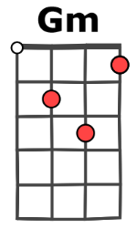  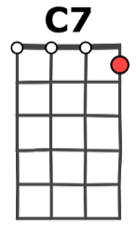  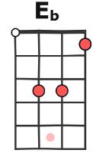  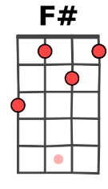  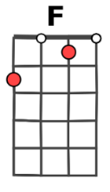  A+G-V1

