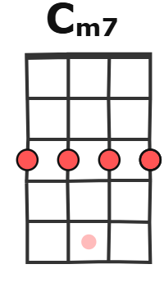 | 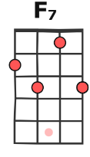
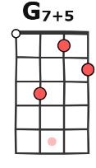 | 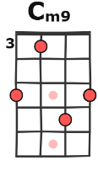  ( Too young to die )
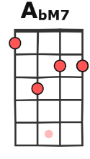 | 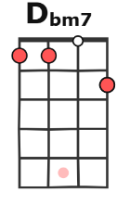  *
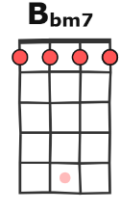 | 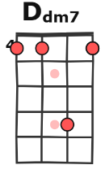
Too Young To Die - Jamiroquai
(1993) BPM102 – Tonalité : Ab major key – Strum funk BxBxBxBx
INTRO
Cm7 | F7 | Cm7 | Cm7 ( 8 temps par accord )
Cm9 | G7+5 | Cm7 | Cm7
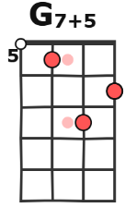
AbM7 | G7+5 | Cm7 | F7
AbM7 | AbM7 | G7+5 | G7+5

COUPLET C Cm7
F7 AbM7 / G7+5 Cm7
Everybody Don’t want no war, No No no no We’re too young to die
F7 AbM7 / G7+5
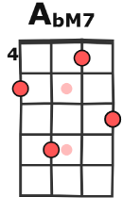
So many people All around the world, yeah
Cm7
( I seen your brother fry)
( All around the world)
Seen their brothers fry
F7 AbM7 / G7+5
What's the motive? In that madness Oh, I wish I knew,
Cm7
you made my people cry
( You made my people cry )
F7 AbM7 /
So politicians This time I think you'd better keep your distance
/ G7+5
Say, sing it loud We're too young to
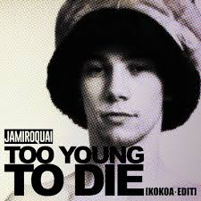
CHORUS
Cm7 Dbm7 Abm7* Bbm7
Do-do-do-doo, da-da-do, da-da-do-do
x 2
Cm7 Dbm7 Abm7* Bbm7
Do-do-do-do, da-da-da, da-da-do

COUPLETvvC Cm7
F7 AbM7 / G7+5 Cm7
What's the answer? I wish I knew, To our problems. I think we've gone too high,
F7 AbM7/ / /G7+5
( I think we've gone too high)
Little children, never said a word now, You know they never said a word,
Cm7 F7 AbM7/
Still they have to die, Well I'm asking why. It won't be long, no no no, Dancing like we do yeah,
/ /G7+5 Cm7
( I gotta put it right)
Oh, like we do now, To put this sad world right.

F7 AbM7 G7+5
So don't you worry, People we won't have to suffer no more, 'Cuz we're too young to...
> CHORUS x 2
>SOLO CUIVRES x2 >SOLO CUIVRES + drums x2 >SOLO trompette et basse x2 >SOLO basse & synth x2

COUPLET
Cm7
All gone when they drop the bomb Can the politicians reassure?
F7
'Cuz here I am assuming that Nobody wants a war.
AbM7 G7+5
There's so many people praying Just to find out if they're staying,
Cm7
But lately stately governments And disillusioned leaders,
F7
So full of empty promises, But rarely do they feed us,
AbM7 G7+5
Put our backs against the wall, Or don't we count at all?
Cm7
Can you decide? Are you mesmerised? Do you know which side you're standing?
F7
'Cuz when it falls gonna take us all, Gotta know what we're demanding.
AbM7 G7+5
I'll never lie can't you hear me cry Coming from on high,
We're too young to die
Outro parlée simultanément
CHORUS
Cm7 Dbm7 Abm7* Bbm7
x 6
Do-do-do-doo, da-da-do, da-da-do-do
Cm7 Dbm7 Abm7* Bbm7
Do-do-do-do, da-da-da, da-da-do

Do-do-do-do-do, da-da-do, da-da-do-do
Now don't you know, I'm too young to die
I'm too young, I'm just too young
Do-do-do-do, da-da-da, da-da-do
Now don't you know, I'm too young to die, yeah
Oh, I'm too young, yeah
I'm just too young
Do-do-do-do, da-da-da, da-da-do

