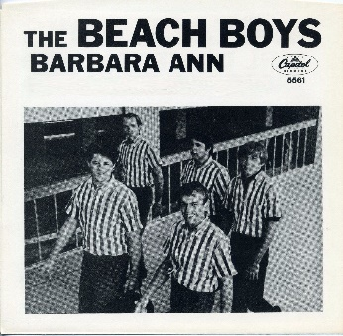
Barbara Ann The Beach boys 1965 Bpm : 78
Tonalité originale
(F#)
Oh Ba-ba-ba-ba-Barbara Ann

(F#) F#
Ba-ba-ba-ba-Barbara Ann Ba-ba-ba-ba-Barbara Ann
Barbara Ann Ta-ake my…
B F#
Ba-ba-ba-ba-Barbara Ann Ba-ba-ba-ba-Barbara Ann
hand Barbara Ann
C#... / B… F#
Ba-ba-ba-Barbara Ann
You got me rockin' and a rollin' Rockin' and a reelin' Barbara Ann

F#... / F#... F#... / F#...
Went to a dance Lookin' for romance Saw Barbara Ann so I thought I'd take a chance on
B F#
Ba-ba-ba-ba-Barbara Ann Ba-ba-ba-ba-Barbara Ann
Barbara Ann take my hand take my hand
C#... / B… F#
Ba-ba-ba-Barbara Ann
You got me rockin' and a rollin' Rockin' and a reelin' Barbara Ann

(F#)
Ba-ba-ba-ba-Barbara Ann
Refrain

(F#) F#
Ba-ba-ba-ba-Barbara Ann Ba-ba-ba-ba-Barbara Ann
Barbara Ann Ta-ake my…
B F#
Ba-ba-ba-ba-Barbara Ann Ba-ba-ba-ba-Barbara Ann
hand Barbara Ann
C#... / B… F#
Ba-ba-ba-Barbara Ann
You got me rockin' and a rollin' Rockin' and a reelin' Barbara Ann

Let’s go Instrumental : F# F# B F# C# / B F#

F#... / F#... F#... / F#...
Tried Peggy Sue Tried Peggy Lou Tried Mary Lou but I knew she wouldn't do
B F#
Ba-ba-ba-ba-Barbara Ann Ba-ba-ba-ba-Barbara Ann
Barbara Ann take Barbara Ann take my hand
C#... / B… F#
Ba-ba-ba-Barbara Ann
You got me rockin' and a rollin' Rockin' and a reelin' Barbara Ann
(F#)
Ba-ba-ba-ba-Barbara Ann
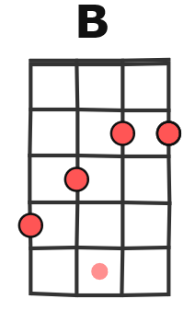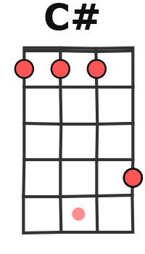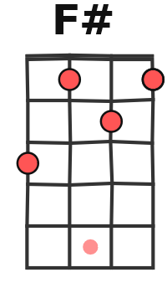

Refrain

F# F# B
Barbara Ann Barbara Ann Barbara Ann Barbara Ann Barbara Ann Barbara Ann
F# C# / B F# F#...
Barbara Ann Barbara Ann
G / V2
Rythme : B.B.B..h.h.hB.Bh

