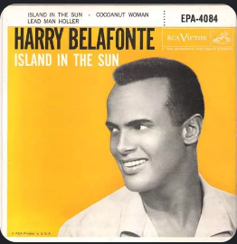
ISLAND IN THE SUN. Harry Belafonte. 1957
Tona originale : D. 66 bpm
Tona : C strum : B BH .H BH

C F G7 C
This is my island in the sun Where my people have toiled since time begun
Am Dm C G7 / C
I may sail on many a sea Her shores will always be home to me

C Dm G7 C
Oh, island in the sun Willed to me by my father's hand
Am F G7 C G7 / C
All my days I will sing in praise Of your forests, waters, your shining sands

Refrain

C F G7 C
As morning breaks the heaven on high I lift my heavy load to the sky
C Dm C G7 / C
Sun comes down with a burning glow Mingles my sweat with the earth below

Refrain

C F G7 C
I see woman on bended knee Cutting cane for her family
Am Dm C G7 / C
I see man at the water side Casting nets at the surging tide

Refrain

C F G7 C
I hope the day will never come That I can't awake to the sound of a drum
Am Dm C G7 / C
Never let me miss carnival With calypso songs philo-sophical

Refrain
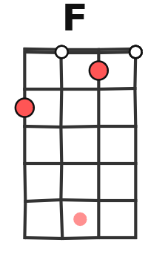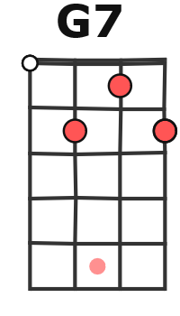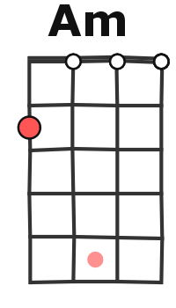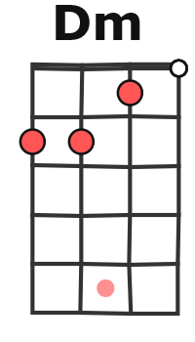
F. / M. V1

