
Our house - Madness (1982)
122 BPM 4/4 Tonalité : C Strum : B B B Bh

INTRO : [ C | Gm | Dm | Fm ] x 3

C Gm
Father wears his Sunday best,
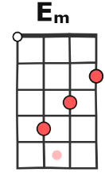 | 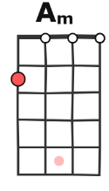
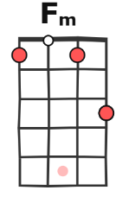 | 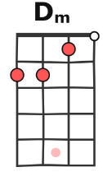
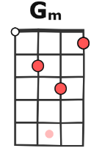 | 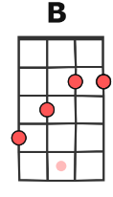
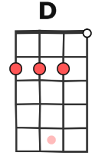 | 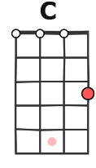
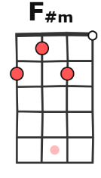 | 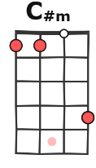
Dm Fm
Mother's tired she needs a rest, the kids are playing up downstairs.
C Gm
Sister's sighing in her sleep,
Dm Fm
Brother's got a date to keep, he can't hang around.

REFRAIN :
D / Am Em / Gm D /
Our house, in the middle of our street,
Am Em / Gm
Our house, in the middle of our...

C Gm
Our house it has a crowd,
Dm Fm
There's always something happening, and it's usually quite loud.
C Gm
Our mum she's so house-proud.
Dm Fm
Nothing ever slows her down, and a mess is not allowed.

- REFRAIN

B / F#m C#m / Em B /
Our house, in the middle of our street,
F#m C#m / Em
Our house, in the middle of our street,
( Something tells you that you've got to get in the middle of it ) > en 2ème voix par-dessus

C Gm Dm Fm
Father gets up late for work, Mother has to iron his shirt, then she sends the kids to school
C Gm
Sees them off with a small kiss. ( aaah aaah aaah aaah )
Dm Fm
She's the one they're going to miss, in lots of ways.

- PONT : [ G / F#m | A / Bm ] x 2

- SOLO : [ C | Gm | Dm | Fm ] x 2

- REFRAIN NB : ralentir progressivement à 115BPM avant de reprendre

C
I remember way back then, when everything was true, and when,
Gm Dm Fm
We would have such a very good time, such a fine time, such a happy time.
C Gm
And I remember how we'd play, simply waste the day away, then we'd say
Dm Fm
Nothing would come be-tween us, two dreamers.

C Gm
Father wears his Sunday best,
Dm Fm
Mother's tired she needs a rest, the kids are playing up downstairs.
C Gm
Sister's sighing in her sleep,
Dm Fm
Brother's got a date to keep, he can't hang around.

REFRAIN > Modulation finale : + 1 ton – 1 ½ ton + ½ ton + 1 ton

D / Am Em / Gm D /
Our house, in the middle of our street
Am Em / Gm (B)
Our house, in the middle of our street

B / F#m C#m / Em B /
Our house, in the middle of our street
F#m C#m / Em (C)
Our house, in the middle of our...


C / Gm Dm / Fm C /
Our house, was our castle and our keep
Gm Dm / Fm (D)
Our house, in the middle of our street

D / Am Em / Gm D /
Our house, that was where we used to meet
Am Em / Gm (B) ad lib
Our house, in the middle of our street
Version n° 2 – 02/20206

