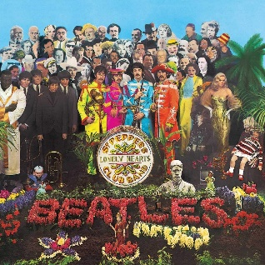
When I'm sixty-four The Beatles 1967 Bpm : 140
Tonalité originale : C Rythme BhBhBhBh
INTRO (riff) : A A D / E7 A // E7 / A A A
A A A E
When I get older losing my hair many years from now
E E E7 A
Will you still be sending me a valentine birthday greetings bottle of wine?
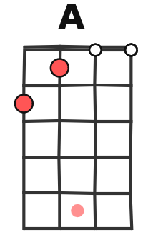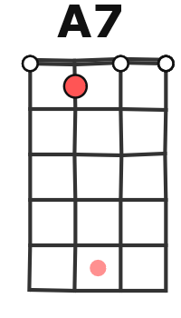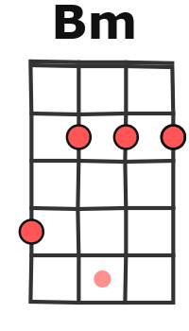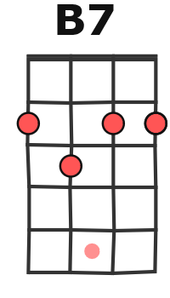
A A A7 D
If I'd been out ‘till quarter to three would you lock the door ?
D / Dm A7 / F#7 B7 / E7 A // E7 / A
Will you still need me will you still feed me when I'm sixty-four ?
F#m F#m E F#m F#m F#m C#7 C#7
Ooo Ooo Ooo You'll be older too
F#m F#m Bm Bm D E A E
Aaaa And if you say the word I could stay with you
-4-5--7-5--4-------2---2-2--------2---5-
----------------7--5-0---0-0------4-------
----------------------4---4-4----4----------
----------------------1---1-1---------------

A A A E
I could be handy mending a fuse when your lights have gone
E E E7 A / A
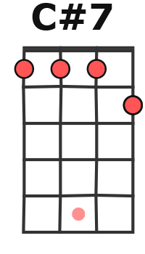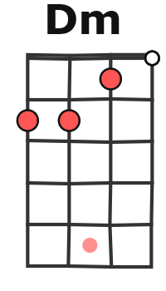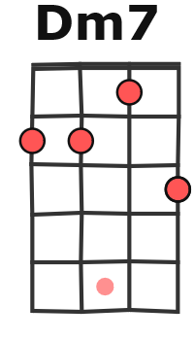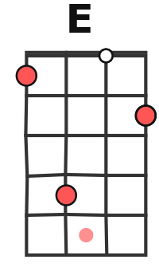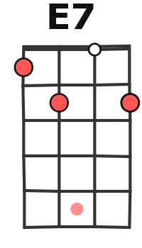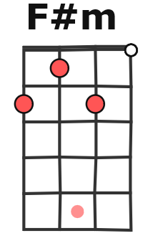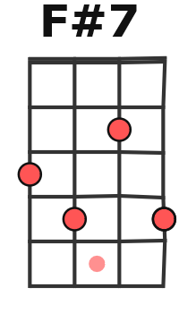
You can knit a sweater by the fireside sunday mornings go for a ride
A A A7 D
Doing the garden digging the weeds who could ask for more ?
D / Dm A7 / F#7 B7 / E7 A // E7 / A
Will you still need me will you still feed me when I'm sixty-four ?

F#m F#m E F#m
Every summer we can rent a cottage in the Isle of Wight if it's not too dear
F#m F#m C#7 C#7
We shall scrimp and save
F#m F#m Bm Bm D E A E
Aaaa Grand children on your knee Ve ra Chuck and Dave

A A A E
Send me a postcard drop me a line Stating point of view
E E E7 A / A
Indicate precisely what you mean to say Yours sincerely wasting Away.
A A A7 D
Give me your answer fill in a form Mine for ever-more
D / Dm A7 / F#7 B7 / E7 A // E7 / A
Will you still need me will you still feed me When I'm sixty-four ?
Outro (riff) : A A D / E7 A//E7/A
G/V2
A/-----------------------------------0----0-2---0-4---2-0---0---2-0-------0
E/---------------0-------0---2-0----------------------------2------------0-
C/---1---0-1-------1-

