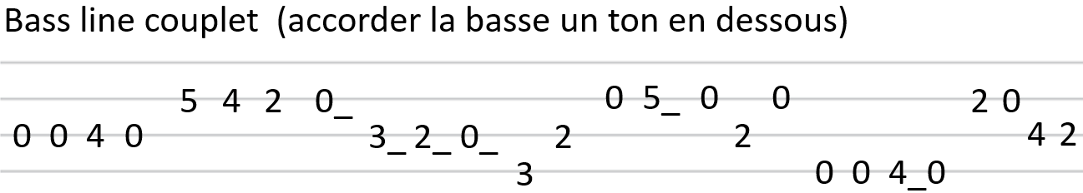
Beginning To See The Light - The Velvet Underground (1969)
INTRO [ G | C | F | D ] x 2
G C F D
Well I'm beginning to see the light x 2
COUPLET 1
G C F D G C F D
Some people working so hard but still they never get it right I'm beginning to see the light
G C F D
( Yeah) I'm beginning to see the light x 2
G C F D G C F %
COUPLET 2
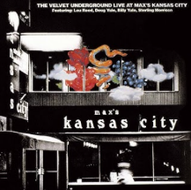
A little wine in the morning some breakfast at night I'm beginning to see the light
F C / Bb Bb C / F F C / Bb Bb C / F
Here we go again playing the fool again Here we go again acting hard again, all right
+ INSTRU [ G C F D ] x 2
PONT
G C F D
Well I'm beginning to see the light x 2
COUPLET 3
G C F D
I wore my teeth in my hands so I could mess the hair of the night,
G C F D
I'm beginning to see the light x 2
COUPLET 4
G C F D G C F D
Yeah I'm beginning to see the light I met myself in a dream but everything was all right
G C F %
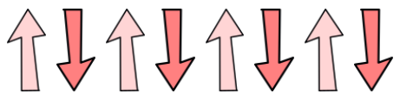
beginning to see the light
F C / F F C / F F C / F F C / F
Here comes two of U which one will you choose, one’s black and one is blue, don't know just what to do, all right
+ Instru [ G C F D ] x 2
PONT 2
G C F D
Yeah I'm beginning to see the light, oh x 2
G C F D
Some people working so hard but never get t’do it right
G C F D
I'm beginning to see the light x 2
G C F D G C F D
Yeah I'm beginning to see the light, There are problems in these times, ooohhh, none of them are mine
G C F %
I'm beginning to see the light
F C / Bb Bb C / F
Here we go again I thought that you were my friend x 2
COUPLET 5
PONT 3
124 BPM

F G Bb C
How does it feel to be loved x 5
OUTRO
+ INSTRU [ F | G | Bb | C ] x 5

