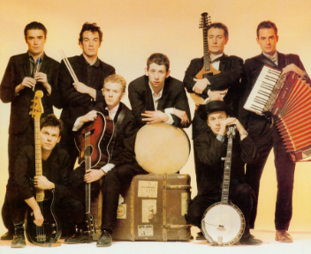
Fairytale of New York – The Pogues
(1988)
Section 1 : Slow verse 4/4 , 1 accord = 4 strum D . D . D . D .
A D G
It was Christmas Eve babe, In the drunktank
D A D
An old man said to me, won't see another one And then he sang a song
G D [ Asus4 / D | A ]
The Rare Old Mountain Dew And I turned my face away And dreamed about you
D G
Got on a lucky one Came in eighteen to one
D A D
I've got a feeling, This year's for me and you, so happy Christmas,
G D [ Asus4.. // D.. ] puis A x 3 temps
I love you baby I can see a better time When all our dreams come true
Section 2 : 1 accord = D D-U D (ternaire 6/8 ) INSTRUMENTAL : [ D, D, D, A, D, G, A, D ]
Section 3 : 1 accord = D D-U D (ternaire 6/8 )
D A Bm G
They've got cars Big as bars they've got rivers of gold
Tonalité en Ré
D D D A
But the wind goes right through you it's no place for the old
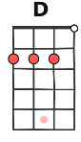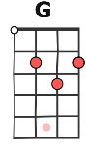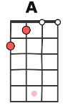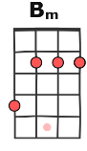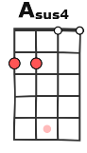
D Bm D G
When you first took my hand on a cold Christmas Eve
D D A D
You promised me Broadway was waiting for me
Section 2 : 1 accord = D D-U D (ternaire 6/8 )
D D D A
You were handsome You were pretty Queen of New York City
D G A D
When the band finished playing they howled out for more
Tempo
D D D A
Sinatra was swinging all the drunks they were singing
4/4, 55 bpm
6/8, 80 bpm
D G A D
We kissed on the corner then danced through the night

Section 4 : Chorus, 1 accord = D D-U D (ternaire 6/8 )
G G G G D D Bm Bm
The boys of the N Y P D choir Were singing 'Galway Bay'
D G A A
And the bells were ringing Out for Christmas day
Section 3 : 1 accord = D D-U D (ternaire 6/8 )
D A Bm G D D D A
D Bm D G D D A D
Section 2 : 1 accord = D D-U D (ternaire 6/8 )
D, D, D, A,
You're a bum You're a punk You're an old slut on junk
CHANT EN DUO :
voix Homme
voix Femme
ensemble
D G A D
Living there almost dead on a drip In that bed
D, D, D, A,
You scum bag You maggot You cheap lousy faggot
D G A D
Happy Christmas your arse I pray God It's our last
Section 4 : Chorus, 1 accord = D D-U D (ternaire 6/8 )
G G G G D D Bm Bm
The boys of the N Y P D choir Were singing 'Galway Bay'
D G A A D D D D A A A .
And the bells were ringing Out for Christmas day
Section 1 : Slow verse 4/4, 1 accord = 4 strum D . D . D . D .
D G
I could have been someone … Well, so could anyone
D A D
You took my dreams From me when I first found you … I kept them with me babe
G D [ Asus4.. // D.. ] A x 3 tps
I put them with my own, can't make it all alone I've built my dreams around you
Section 4 : Chorus, 1 accord = D D-U D (ternaire 6/8 )
G G G G D D Bm Bm
The boys of the N Y P D choir Were singing 'Galway Bay'
D G A A
And the bells were ringing Out for Christmas day

Section 5 : Outro 4/4 Instrumentale x 2 1 accord = 4 strums vers le bas
[ D | G | D | A / . . ]
[ D | G | D | A - D / . . ]

4 sections in odd order
Section 1 : Slow verse x 2
Section 2 : instrumental ( same as you’re handsome you’re pretty)
Section 3 : « They got cars »
Section 4 : Chorus
Section 3 : Instrumental
Section 2 : « You’re a bum »
Section 4 : Chorus
Section 1 : to end « I could have been someone »
Section 4 : Chorus
Section 5 : Outro

