Hey Jude (The Beatles)
Couplets :
1 & 2 & 3 & 4 &
A..x……..x……x……x…..
E..x……..x……x……x…..
C……x...…..x……x……x
G..x……..x……x……x….
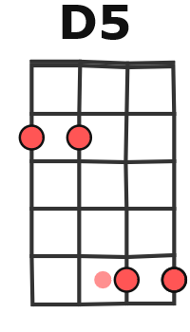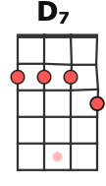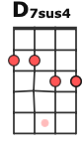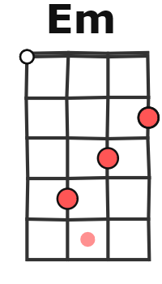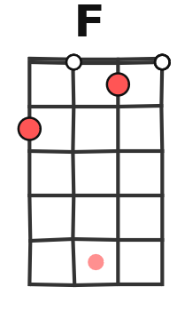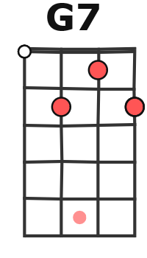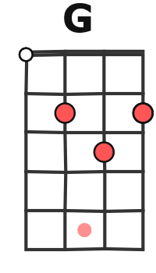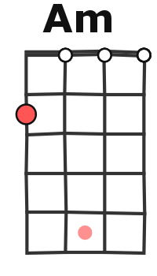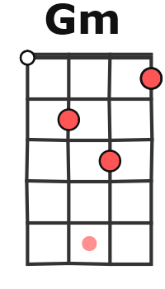
1968, 147 BPM en G = +1 ton

G D [D7(1)D7sus4(2,3)D7(4)] G
(Ré) Hey Jude, don't make it bad. Take a sad song and make it bet-ter.
C G D7 G / G↓
Re-member to let her into your heart, Then you can start to make it bet-ter.
G D [D7(1)D7sus4(2,3)D7(4)] G
Hey Jude, don't be afraid, You were made to go out and get her.
C G D7 G
4 &
e3 e2
The minute you let her under your skin, Then you be-gin to make it bet-ter

G7 C / Em
REFRAIN
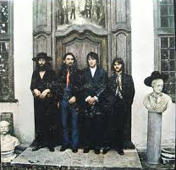
And anytime you feel the pain, hey Jude,
4 &
e3 e2
Am / C D / D7 G
B b B b x 2
Re-frain, don't car-ry the world up-on your shoul-ders.
G7 C / Em
& 4 &
e3 c2 c4
For well you know that it's a fool who plays
Am / C D / D7 G
It cool by making his world a lit-tle cold-er. Na na na
1 & 2 3
E..2…3…5…….5 à la place du dernier D7
C…………………
G..2…4…5…….5

1 2 3 & 4 1 (2) 1
G7↓ ↓ / D7↓ D7sus4↓ D5↓ D5↓ (2 tps) D7
Na na Na na na Na

G D [D7(1)D7sus4(2,3)D7(4)] G
Hey Jude, don't let me down, You have found her, now go and get her.
C G D7 G
4 &
e3 e2
4 &
e1 e0
Re-member to let her into your heart, Then you can start to make it bet-ter.

G7 C / Em
REFRAIN
So let it out and let it in, hey Jude,
4 & e3 e2
Am / C D / D7 G
B b B b x 2
Be-gin, you're waiting for some-one to per-form with.
G7 C / Em
& 4 &
e3 c2 c4
And don't you know that it's just you, hey Jude,
Am / C D / D7 G
You'll do, the movement you need is on your shoul-der. Na na na
1 & 2 3
E..2…3…5…….5 à la place du dernier D7
C…………………
G..2…4…5…….5

1 2 3 & 4 1 (2) 1
G7↓ ↓ / D7↓ D7sus4↓ D5↓ D5↓ (2 tps) D7
Na na Na na na Na

G D [D7(1)D7sus4(2,3)D7(4)] G
Hey Jude, don't make it bad. Take a sad song and make it bet-ter.
C G D7 G
Re-member to let her under your skin, Then you begin to make it bet-ter
G / G↓
Better better better better better, oh.
B b B b x 2
G F C G x5 puis (percu/chant) puis (basse/chant)
Na na na nananana, nananana, hey Jude fin : 1x en ralentissant G…
M-A V2

