Baby Jane Rod Stewart 1983 Bpm : 123
Rythme : B Bh hBh x2
Tonalité originale
Intro : Dm / Am7 Bb x2
F C Dm Bb
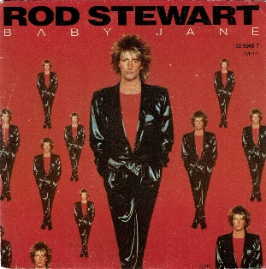
Baby Jane don't leave me hangin' on the line I knew you when you had no one to talk to
F C Dm / Bb C7
Now you're moving in high society Don't forget I know secrets about you
Bb / Am Gm / Gm7
I used to think you were on my side But now I'm no longer sure.
Bb / Am C
I wish I knew what I know now befo-o-ore
Dm / Am7 Gm7 / Gm7//Am7-C
When I give my heart again I know it's gonna last forever.
Dm / Am7 Gm7 / Gm7//Am7-C Dm / Am7 Bb
No one tell me where or when I know it's gonna last forever.
F C Dm Bb
Baby Jane don't it make you feel sad Just when I thought that we were winning
F C Dm / Bb C7
You and I were so close in ev'ry way Don't time fly when you're loving and laughing
Bb / Am Gm / Gm7
I've said goodbye so many times the situation ain't all that new
Bb / Am C
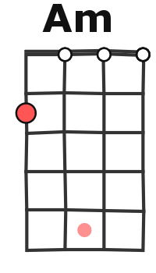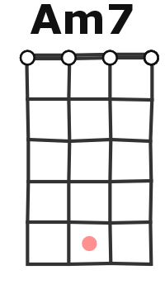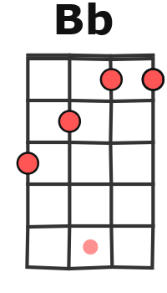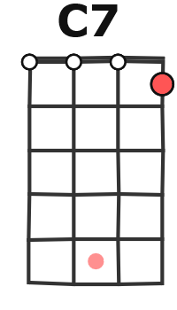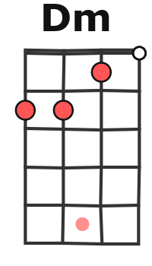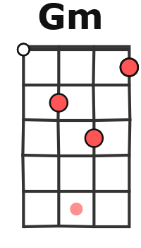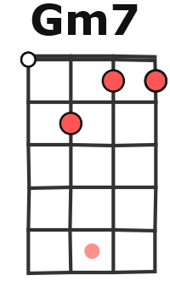
Optimism's my best defense I'll get through without you
Dm / Am7 Gm7 / Gm7//Am7-C
When I give my heart again I know it's gonna last forever
Dm / Am7 Gm7 / Gm7// Am7-C
No one tell me where or when I know it's gonna last forever
Dm / Am7 Gm7 / Gm7// Am7-C
I won’t be that dumb again I know it's gonna last forever
Dm / Am7 Gm7 / Gm7//Am7-C Dm / Am7 Bb
When I fall in love again I know it's gonna last forever
Solo : F C Dm / Bb C

F C Dm Bb
Baby Jane I've said all I want to say Go your own way don't think twice about me
F C Dm / Bb C7
'Cause I've got ideas and plans of my own So long dar-ling I'll miss you believe me
Bb / Am Gm / Gm7
The lesson learned was so hard to swallow but I know that I'll survive
Bb / Am C
I'm gonna take a good look at myself and cry-y-y yeah
Dm / Am7 Gm7 / Gm7//Am7-C
When I give my heart again I know it's gonna last forever
Dm / Am7 Gm7 / Gm7//Am7-C
No one tell me where or when I know it's gonna last forever
Dm / Am7 Gm7 / Gm7// Am7-C
I won’t be that dumb again I know it's gonna last forever
Dm / Am7 Gm7 / Gm7//Am7-C Dm / Am7 Bb x2
When I fall in love again I know it'll last forever
G / V1

