Baby Jane Rod Stewart 1983 Bpm : 123
Rythme : B Bh hBh x2
Tonalité originale : Dm
Intro : F#m / C#m7 D x2
A E F#m D
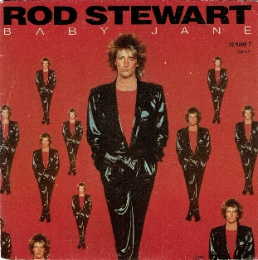
Baby Jane don't leave me hangin' on the line I knew you when you had no one to talk to
A E F#m / D E7
Now you're moving in high society Don't forget I know secrets about you
D / C#m Bm / Bm7
I used to think you were on my side But now I'm no longer sure.
D / C#m E
I wish I knew what I know now befo-o-ore
F#m / C#m7 Bm7 / Bm7//C#m7-E
When I give my heart again I know it's gonna last forever.
F#m / C#m7 Bm7 / Bm7//C#m7-E F#m / C#m7 D
No one tell me where or when I know it's gonna last forever.
A E F#m D
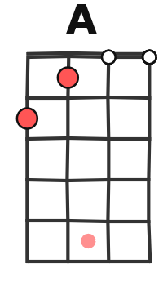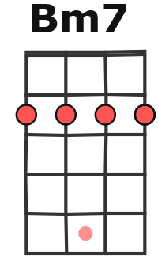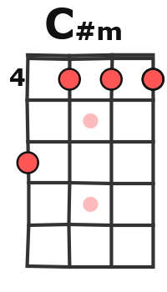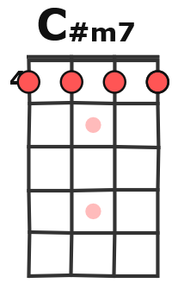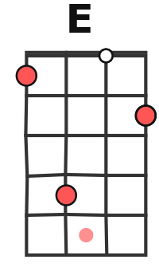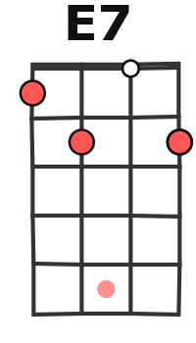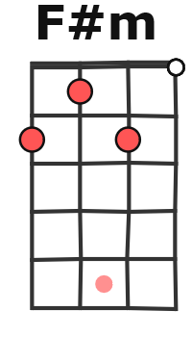
Baby Jane don't it make you feel sad Just when I thought that we were winning
A E F#m / D E7
You and I were so close in ev'ry way Don't time fly when you're loving and laughing
D / C#m Bm / Bm7
I've said goodbye so many times the situation ain't all that new
D / C#m E
Optimism's my best defense I'll get through without you
F#m / C#m7 Bm7 / Bm7//C#m7-E
When I give my heart again I know it's gonna last forever
F#m / C#m7 Bm7 / Bm7// C#m7-E
No one tell me where or when I know it's gonna last forever
F#m / C#m7 Bm7 / Bm7// C#m7-E
I won’t be that dumb again I know it's gonna last forever
F#m / C#m7 Bm7 / Bm7//C#m7-E F#m / C#m7 D
When I fall in love again I know it's gonna last forever
Solo : A E F#m / D E

A E F#m D
Baby Jane I've said all I want to say Go your own way don't think twice about me
A E F#m / D E7
'Cause I've got ideas and plans of my own So long dar-ling I'll miss you believe me
D / C#m Bm / Bm7
The lesson learned was so hard to swallow but I know that I'll survive
D / C#m E
I'm gonna take a good look at myself and cry-y-y yeah
F#m / C#m7 Bm7 / Bm7//C#m7-E
When I give my heart again I know it's gonna last forever
F#m / C#m7 Bm7 / Bm7//C#m7-E
No one tell me where or when I know it's gonna last forever
F#m / C#m7 Bm7 / Bm7// C#m7-E
I won’t be that dumb again I know it's gonna last forever
F#m / C#m7 Bm7 / Bm7//C#m7-E F#m / C#m7 D x2
When I fall in love again I know it'll last forever
G / V1

