These boots are made for walkin’ Nancy Sinatra 1966
Bpm : 83 Tonalité originale
A / 7-7-6-6-5-5-4-4-3-3-2-2-1-1-0----
E / 0-0-0-0-0-0-0-0-0-0-0-0-0-0-0-3-

Rythme couplet : B BhB Bh
Rythme refrain : B Bh hBh

Intro / [Descente] :

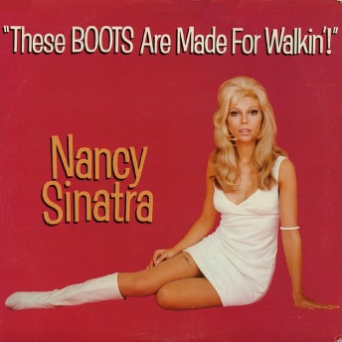
E E E E E E E E
You keep sayin' you've got somethin' for me
E E E E
Somethin' you call love but confess
A A A A
You've been a'messin' where you shouldn't 've been a'messin'
E E E E
And now someone else is getting all your best
Refrain
G E
These boots are made for walkin'
G E
And that's just what they'll do
G E [Descente]
One of these days these boots are gonna walk all over you
E E E E E E E E
You keep lyin' when you oughta be truthin'
E E E E
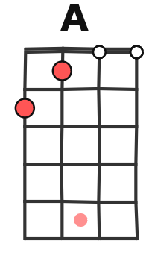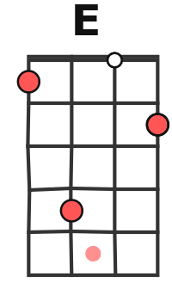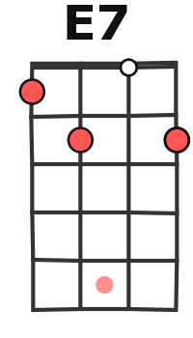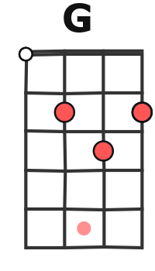
And you keep losing when you oughta not bet
A A A A
You keep samin' when you oughta be a'changin'
E E E E
Now what's right is right but you ain't been right yet

Refrain
E E E E E E E E
You keep playin' where you shouldn't be playin'
E E E E
And you keep thinkin' that you'll never get burnt ha
A A A A
I just found me a brand new box of matches yeah
E E E E
And what he knows you ain't had time to learn
Refrain

E E E E E E E
Are you ready, boots? Start walkin' x3
A / 7-----------5-6-7-------------5-6- -7---
E / -----7----7-----------7----7------- ------
G / V2

