
Counting Stars OneRepublic 2013
Intro : Arpège GCEA, Strum : B-B-B-Bh
122 bpm. Tonalité
Am C G F
Lately, I been, I been losin' sleep, Dreamin' about the things that we could be
Am C G F
But, baby, I been, I been prayin' hard, Said, "No more countin' dollars, we'll be countin' stars
F I
Intro
Yeah, we'll be countin' stars"
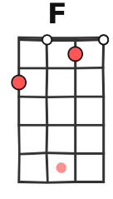
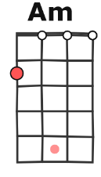
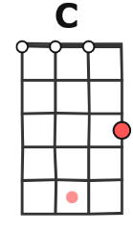
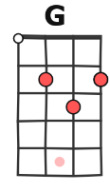
Am C G F Am C G F
Am C
I see this life like a swingin' vine, Swing my heart across the line
G F
In my face is flashin' signs, Seek it out and ye shall find

Am C
The old, but I'm not that old, Young, but I'm not that bold
G F
And I don't think the world is sold, On just doin' what we're told
Am C G F Am C G F
I-iiiii feel somethin' so right doin' the wrong thing, And I-iiiii feel somethin' so wrong doin' the right thing
F F F↓
I couldn't lie, couldn't lie, couldn't lie, Everything that kills me makes me feel alive
Am C G F
Refrain
Lately, I been, I been losin' sleep, Dreamin' about the things that we could be
Am C G F
But, baby, I been, I been prayin' hard, Said, "No more countin' dollars, we'll be countin' stars"

Am C G F
Lately, I been, I been losin' sleep, Dreamin' about the things that we could be
Am C G F
But, baby, I been, I been prayin' hard, Said, "No more countin' dollars, we'll be, we'll be countin' stars",
Am C G F
……….yeah

Am… C…
I feel your love, and I feel it burn, Down this river, every turn
G… F…
Hope" is our four-letter word, Make that money, watch it burn
Am C
Old, but I'm not that old, Young, but I'm not that bold
G F
And I don't think the world is sold, On just doin' what we're told
Am C G F
And I-iiiii feel somethin' so wrong doin' the right thing
F F F↓
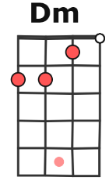
I couldn't lie, couldn't lie, couldn't lie, Everything that drowns me makes me wanna fly
Refrain

Take that money, watch it burn, Sink in the river the lessons I learned X4 (percussion)
F… Dm…
Everything that kills me makes me feel alive
Refrain


Am C
Take that money, watch it burn, Sink in the river the lessons I learned
X2
G F (2ème= F↓ pour finir)
Take that money, watch it burn, Sink in the river the lessons I learned
A

