
Wonderwall (Oasis, 1995) VO : F#m, Transpo : Em. 88 BPM
Couplet
et Refrain
1 & 2 & 3 & 4 & 5 & 6 & 7 & 8 & 1 & 2 & 3 & 4 & 5 & 6 & 7 & 8 &
B B B B h B h B B B h B h B B B h h h B h B h
h B h B h B B h
Prérefrain
B B B B h B B B B h B B B B h h B h B h B h

INTRO : Em7 / G Dsus4 / A7sus4 x 4

Em7 / G Dsus4 / A7sus4
Today is gonna be the day that they're gonna throw it back to you
Em7 / G Dsus4 / A7sus4
By now you should've somehow realized what you gotta do
Em7 / G Dsus4 / A7sus4 Cadd9 / Dsus4 A7sus4
I don't believe that an-ybody feels the way I do, about you now

Em7 / G Dsus4 / A7sus4
Backbeat, the word was on the street that the fire in your heart is out
Em7 / G Dsus4 / A7sus4
I'm sure you've heard it all before but you never really had a doubt
Em7 / G Dsus4 / A7sus4 Em7 / G Dsus4 / A7sus4
I don't believe that an-ybody feels the way I do, about you now

Cadd9 / Dsus4 Em7 Cadd9 / Dsus4 Em7
And all the roads we have to walk are wind-ing, and all the lights that lead us there are blind-ing
Cadd9 / Dsus4 G↓ // Dsus4↓ // Em7↓ ↓↑ // G↓ A7sus4 A7sus4
There are many things that I would like to say to you but I don't know how

Cadd9 / Em7 G / Em7 Cadd9 / Em7
Because maybe………….. you're gon-na be the one that saves me
G / Em7 Cadd9 / Em7 G / Em7 Cadd9 / Em7 G / Em7↓ (↓) (1mesure)
And after all……………….…. you're my wonderwall

Em7 / G Dsus4 / A7sus4
Today was gonna be the day but they'll never throw it back to you
Em7 / G Dsus4 / A7sus4
By now you should've somehow realized what you’re not to do
Em7 / G Dsus4 / A7sus4 Em7 / G Dsus4 / A7sus4
I don't believe that an-ybody feels the way I do, about you now

Cadd9 / Dsus4 Em7 Cadd9 / Dsus4 Em7
And all the roads that lead you there were wind-ing, and all the lights that light the way are blind-ing
Cadd9 / Dsus4 G↓ // Dsus4↓ // Em7↓ ↓↑ // G↓ A7sus4 A7sus4
There are many things that I would like to say to you but I don't know how
Cadd9 / Em7 G / Em7 Cadd9 / Em7
I said maybe…………. you're gon-na be the one that saves me
x 2
G / Em7 Cadd9 / Em7 G / Em7 Cadd9 / Em7 G / Em7
And after all……………….…. you're my wonderwall

Cadd9 / Em7 G / Em7 Cadd9 / Em7
I said maybe…………. you're gon-na be the one that saves me
G / Em7 Cadd9 / Em7
x 2
You're gon-na be the one that saves me
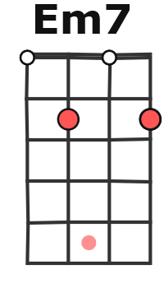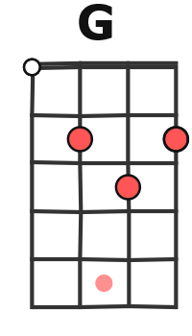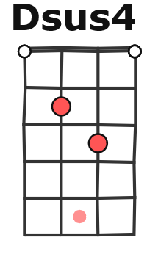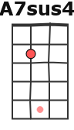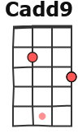

FIN : G / Em7 (Cadd9 / Em7 G / Em7) x 4
MA + G / V1

