
Snowman Sia 2017
69 bpm. Tonalité C
C
A ||-‐ -‐ -‐ -- 3 -- -- -- -- -- 3 -- -- -- -- -‐ 3 -- -- 3
E ||-‐ -‐ -- 0 -‐ 0 -‐ -‐ -- 0 -- 0 -- -- -- 0 -‐ -- -0 -‐
C II-- -- 0 -- -- -- 0 -- 0 -- -- -- 0 -- 0 -- -- ---- -- G ||-‐ 0 -‐ -- -- -- -- 0 -- -- -- -- -- 0 -‐ -- -- 0 -- -- -

Intro

Couplet 1
Dm Dm
Refrains

Couplets
Don't cry, snowman, not in front of me
G G C
Who'll catch your tears if you can't catch me, darling ?
A ||-‐ -‐ --A -A --
E ||-‐ -‐ --M-M
C II-- -- --I - I -- G ||-‐ P -‐ -- --
A ||-‐ -‐ -‐ -- A -- --
E ||-‐ -‐ -- M -‐ M -‐
C II-- -- I -- -- -- - I G ||-‐ P -‐ -- -- -- --
C Am Am
If you can't catch me, darling
Dm Dm
Don't cry, snowman, don't leave me this way
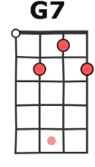
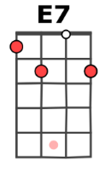
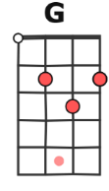
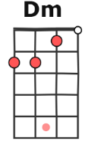
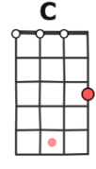
G G C
A puddle of water can't hold me close, baby
C Am Am
Can't hold me close, baby
Refrain
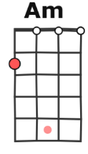
E7 E7 Am Am
I want you to know that I'm never leaving
G G C C
Cause I'm Mrs. Snow, 'til death we'll be freezing
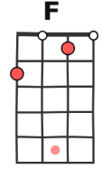
E7 E7 Am Am
Yeah, you are my home, my home for all seasons
F F G7 G7
So come on, let's go
C C E7 E7
Let's go below zero and hide from the sun
Am Am F F
I love you forever where we'll have some fun
C C E7 E7
Yes, let's hit the North Pole and live happily
Am Am F F
Please, don't cry no tears now, it's Christmas, baby
C C E7 E7 Am Am F F C C E7 E7 Am Am F F
My snowman and me eh My snowman and me -e-e -e Baby
C
A ||-‐ -‐ -‐ -- 3 -- -- -- -- -- 3 -- -- -- -- -‐ 3 -- -- 3
E ||-‐ -‐ -- 0 -‐ 0 -‐ -‐ -- 0 -- 0 -- -- -- 0 -‐ -- -0 -‐
C II-- -- 0 -- -- -- 0 -- 0 -- -- -- 0 -- 0 -- -- ---- -- G ||-‐ 0 -‐ -- -- -- -- 0 -- -- -- -- -- 0 -‐ -- -- 0 -- -- -

Dm Dm
Couplet 2
Don't cry, snowman, don't you fear the sun
G G C
Who'll carry me without legs to run, honey ?
C Am Am
Without legs to run, honey
Dm Dm
Don't cry, snowman, don't you shed a tear
G G C
Who'll hear my secrets if you don't have ears, baby ?
C Am Am

If you don't have ears, baby
C…
Refrain
C
A ||-‐ -‐ -‐ -- 3 -- -- -- -- -- 3 -- -- -- -- -‐ 3 -- -- -- -
E ||-‐ -‐ -- 0 -‐ 0 -‐ -‐ -- 0 -- 0 -- -- -- 0 -‐ -- --0 --
C II-- -- 0 -- -- -- 0 -- 0 -- -- -- 0 -- 0 -- -- -- -- -- -G ||-‐ 0 -‐ -- -- -- -- 0 -- -- -- -- -- 0 -‐ -- -- 0 -- -- --

A-V2

