Moonlight Shadow. Mike Olfield. 1983. Tonalité originale : E. tona : G. 129bpm
INTRO : Bb F Gm / Eb F
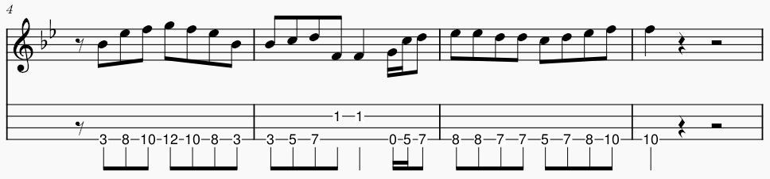

Gm Eb F Bb / F
B Bh .h Bh ou B Bh B Bh
The last that ever she saw him Carried away by a moonlight shadow
Gm Eb F Bb / F
He passed on worried and warning Carried away by a moonlight shadow.
Bb F Gm / Eb F
Lost in a riddle that Saturday night Far away on the other side.
Bb F Gm / Eb F
He was caught in the middle of a desperate fight And she couldn't find how to push through
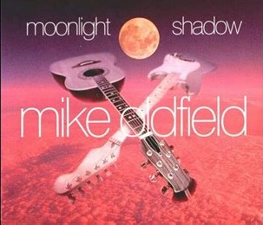
Gm Eb F Bb / F
The trees that whisper in the evening Carried away by a moonlight shadow
Gm Eb F Bb / F
Sing a song of sorrow and grieving Carried away by a moonlight shadow
Bb F Gm / Eb F
All she saw was a silhouette of a gun Far away on the other side.
Bb F Gm / Eb F
He was shot six times by a man on the run And she couldn't find how to push through
F… F… Bb / Eb F F… F… Bb / Eb F
I stay I pray I See you in heaven far away I stay I pray I See you in heaven one day

REFRAIN

Gm Eb F Bb / F
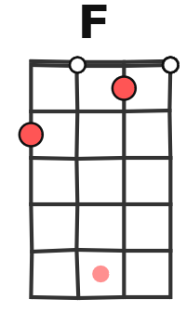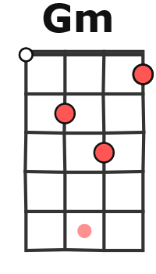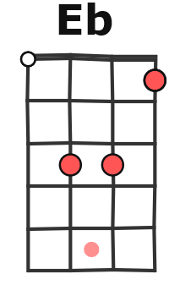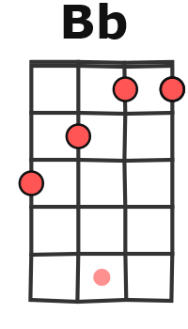
Four a.m in the morning Carried away by a moonlight shadow
Gm Eb F Bb / F
I watched your vision forming Carried away by a moonlight shadow
Bb F Gm/Eb F
Star was light in a silvery night Far away on the other side
Bb F Gm / Eb F
Will you come to talk to me this night But she couldn't find how to push through
REFRAIN
INSTRU : Gm Eb F Bb / F Gm Eb F Bb / F Bb F Gm / Eb F
Far away on the other side
Bb F Gm / Eb F Gm Eb F Bb / F Gm Eb F Bb / F

Bb F Gm / Eb F
Caught in the middle of a hundred and five
Bb F Gm / Eb F
The night was heavy and the air was alive But she couldn't find how to push through
Gm Eb F Bb / F Gm (Eb F Bb / F
Carried away by a moonlight shadow Carried away by a moonlight shadow
Bb F Gm / Eb F Gm…
Far away on the other side. )
M. V1

