
Moonlight Shadow. Mike Olfield 1983
Tonalité originale : E. tona : F 129bpm

INTRO : F C Dm / Bb C

Dm Bb C F / C
The last that ever she saw him Carried away by a moonlight shadow
Dm Bb C F / C
B Bh .h Bh ou B Bh B Bh
He passed on worried and warning Carried away by a moonlight shadow.
F C Dm / Bb C
Lost in a riddle that Saturday night Far away on the other side.
F C Dm / Bb C
He was caught in the middle of a desperate fight And she couldn't find how to push through
Dm Bb C F / C
The trees that whisper in the evening Carried away by a moonlight shadow
Dm Bb C F / C
Sing a song of sorrow and grieving Carried away by a moonlight shadow
F C Dm / Bb C
All she saw was a silhouette of a gun Far away on the other side.
F C Dm / Bb C
He was shot six times by a man on the run And she couldn't find how to push through
C… C… F / Bb C C… C… F / Bb C
I stay I pray I See you in heaven far away I stay I pray I See you in heaven one day

REFRAIN

Dm Bb C F / C
Four a.m in the morning Carried away by a moonlight shadow

Dm Bb C F / C
I watched your vision forming Carried away by a moonlight shadow
F C Dm / Bb C
Star was light in a silvery night Far away on the other side
F C Dm / Bb C
Will you come to talk to me this night But she couldn't find how to push through

REFRAIN

INSTRU : Dm Bb C F/C Dm Bb C F/C F C Dm / Bb C
Far away on the other side
F C Dm/Bb C Dm Bb C F/C Dm Bb C F/C

F C Dm Bb / C
Caught in the middle of a hundred and five
F C Dm / Bb C
The night was heavy and the air was alive But she couldn't find how to push through
Dm Bb C F / C Dm ( Bb C F / C
Carried away by a moonlight shadow Carried away by a moonlight shadow
F C Dm / Bb C
Far away on the other side. )
M. V1

INTRO F C Dm / Bb C
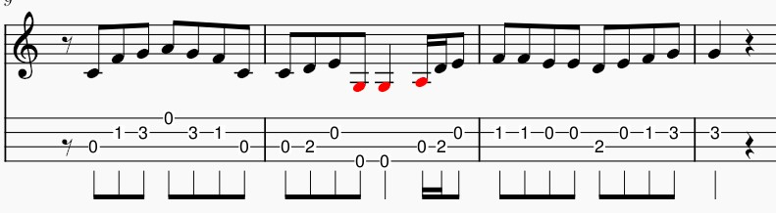
Intro Low G

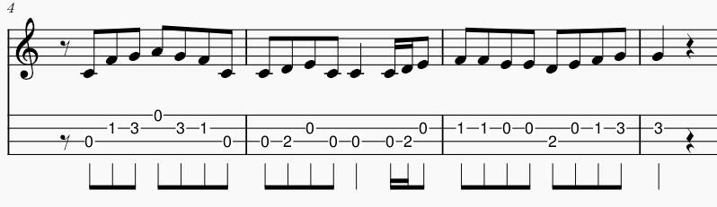

Intro High G

