Moonlight Shadow. Mike Olfield Tona originale : E. tona : C 129bpm
INTRO C G Am / F G

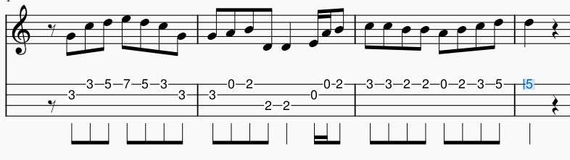

Am F G C / G
B Bh .h Bh ou B Bh B Bh
The last that ever she saw him Carried away by a moonlight shadow
Am F G C / G
He passed on worried and warning Carried away by a moonlight shadow.
C G Am / F G
Lost in a riddle that Saturday night Far away on the other side.
C G Am / F G
He was caught in the middle of a desperate fight And she couldn't find how to push through

Am F G C / G
The trees that whisper in the evening Carried away by a moonlight shadow
Am F G C / G
Sing a song of sorrow and grieving Carried away by a moonlight shadow
C G Am / F G
All she saw was a silhouette of a gun Far away on the other side.
C G Am / F G
He was shot six times by a man on the run And she couldn't find how to push through
G… G… C / F G G… G… C / F G
I stay I pray I See you in heaven far away I stay I pray I See you in heaven one day

REFRAIN

Am F G C / G

Four a.m in the morning Carried away by a moonlight shadow
Am F G C / G
I watched your vision forming Carried away by a moonlight shadow
C G Am / F G
Star was light in a silvery night Far away on the other side
C G Am / F G
Will you come to talk to me this night But she couldn't find how to push through
REFRAIN
INSTRU : Am F G C / G Am BF G C / G C G Am / F G
Far away on the other side
C G Am / F G Am F G C / G Am F G C / F G

C G Am F / G
Caught in the middle of a hundred and five
C G Am / F G
The night was heavy and the air was alive But she couldn't find how to push through
Am F G C / G Am ( F G C / G
Carried away by a moonlight shadow Carried away by a moonlight shadow
C G Am / F G
Far away on the other side. )
M. V1

