Moonlight Shadow. Mike Olfield. 1983. Tonalité originale : E. tona : A . 129bpm
INTRO : A E F#m / D E
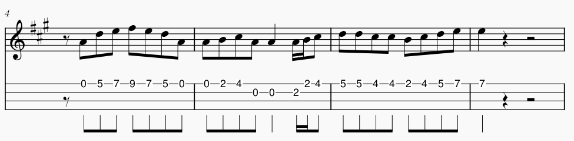

F#m D E A / E
B Bh .h Bh ou B Bh B Bh
The last that ever she saw him Carried away by a moonlight shadow
F#m D E A / E
He passed on worried and warning Carried away by a moonlight shadow.
A E F#m / D E
Lost in a riddle that Saturday night Far away on the other side.
A E F#m / D E
He was caught in the middle of a desperate fight And she couldn't find how to push through
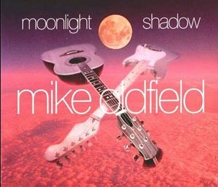
F#m D E A / E
The trees that whisper in the evening Carried away by a moonlight shadow
F#m D E A / E
Sing a song of sorrow and grieving Carried away by a moonlight shadow
A E F#m / D E
All she saw was a silhouette of a gun Far away on the other side.
A E F#m / D E
He was shot six times by a man on the run And she couldn't find how to push through
E… E… A / D E E… E… A / D E
I stay I pray I See you in heaven far away I stay I pray I See you in heaven one day

REFRAIN

F#m D E A / E
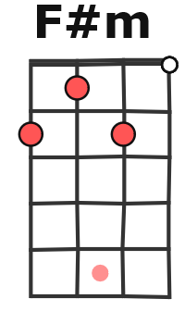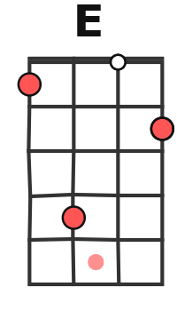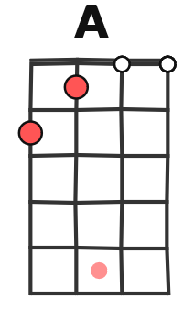
Four a.m in the morning Carried away by a moonlight shadow
F#m D E A / E
I watched your vision forming Carried away by a moonlight shadow
A E F#m / D E
Star was light in a silvery night Far away on the other side
A E F#m / D E
Will you come to talk to me this night But she couldn't find how to push through
REFRAIN
INSTRU : F#m D E A/E F#m D E A/E A E F#m /D E
Far away on the other side
A E F#m/D E F#m D E A/E F#m D E A/E

A E F#m / D E
Caught in the middle of a hundred and five
A E F#m / D E
The night was heavy and the air was alive But she couldn't find how to push through
F#m D E A / E F#m (D E A / E
Carried away by a moonlight shadow Carried away by a moonlight shadow
A E F#m / D E
Far away on the other side. )
M. V1

