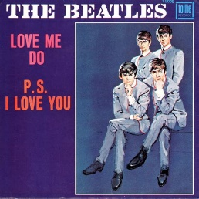
Love me do. The Beatles. 1962
Tonalité : C. 148 bpm
Sur 2 accords
1 2 3 4 1 2 3 4
B Bh B Bh B Bh .h Bh

Intro : G C G C G C G G

G C G C
Love, love me do You know I love you
G C C C C↓
I'll always be true So pleeeeeease...
N.C. G7 C G C
Love me do Woah love me do

X2







D D C / F G
Someone to love, somebody new
D D C / F G↓↓↓
Someone to love, someone like you

G C G C
Love, love me do You know I love you
G C C C C↓
I'll always be true So pleeeeeease...
N.C. G7 C G C
Love me do Woah love me do

D D C/F G D D C/F G G C G G↓

G C G C
Love, love me do You know I love you
G C C C C↓
I'll always be true So pleeeeeease...
N.C. G7 C G C
Love me do Woah love me do
G7 C G C
Love me do Woah love me do… ad libitum + G

M. V1

