Candy Candy Iggy Pop & Kate Pierson 1990 BPM : 144 Tonalité originale

G G C Em G G C Em
It's a rainy afternoon In nineteen ninety The big city
G G C Em G G C Em
geez it's been 20 years Candy you were so fine

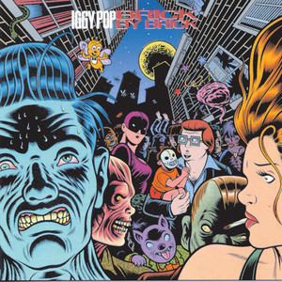
G G C Em
Beautiful beautiful girl from the north
G G C D
You burned my heart with a flickering torch
D Bm Bm C C
I had a dream that no one else could see
Am Am D C D C
You gave me love for free
Refrain

D D C Bm / Am // G
Candy Candy Can-dy I can't let you go
D D C Bm / Am // G
All my life you're haunting me I loved you so
D D C Bm / Am // G
Candy Candy Can-dy I can't let you go

Em Em C C Em Em C C
Life is crazy Can dy ba by
Rythme : B B B B

G G C Em
Yeah, well it hurt me real bad when you left

G G C Em
I'm glad you got out but but I miss you

G G C Em
I've had a hole in my heart for so long
G G C D
I've learned to fake it and just smile along
D Bm Bm C C
Down on the street Those men are all the same
Am Am D C D C
I need a love Not games Not games

Refrain

Em Em C C Em Em C C Em Em C C D C D C
Life is crazy I know ba by Can dy ba by

Refrain
G / V1
D D C Bm / Am // G
Candy Candy Can-dy Life is crazy

D D C Bm / Am // G (x2) D D C Bm / Am // G D
Candy baby Candy candy

