
Complicated (Avril Lavigne, 2002) 156 BPM

Intro : Dm F / C Dm F / C
Uh huh, life's like this, Uh huh, uh huh, that's the way it is
Dm F / C Dm F / C
Intro :
1 2 3 4 5 6 7 8
b b B b b B
'Cause life's like this, Uh huh, uh huh, that's the way it is

F Dm
Chill out, what ya yellin' for ? Lay back, it's all been done before
Bb C
Couplet + pré-REFRAIN
+ PONT
1 2 3 4 5 6 7 8
B B h hB B
And if, you could only let it be, you will see
F Dm
I like you the way you are when we're driving in your car
Bb C
And you're talking to me one on one, but you become

Bb Dm
Pré-REFRAIN
Somebody else 'round everyone else, watching your back like you can't relax,
Bb C
You try to be cool, you look like a fool to me… Tell me
R
E
F
R
A
I
N
Dm / Bb F / C
Why'd you have to go and make things so complica-ted ? I see the way you're
Dm / Bb F / C
acting like you're somebody else gets me frustra-ted and life's like this, you
Dm / Bb F / C
And you fall, and you crawl, and you break and you take what you get, and you turn it into
Gm i . i . i . i . Bb i . . . . . . .
REFRAIN
1 2 3 4 5 6 7 8
B B B B B B
Honesty and promise me I'm never gonna find you fa-king,

F
No, no, no

F Dm
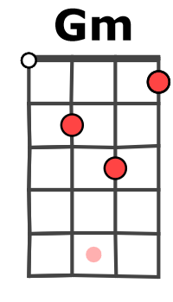
You come over unannounced, dressed up like you're somethin' else
Bb C
Where you are and where it's at you see, you're making me
F Dm
Laugh out when you strike your pose, take off all your preppy clothes
Bb C
You know you're not fooling anyone when you become
Pré-REFRAIN
REFRAIN
PONT : F Dm Bb C
No, no, no No, no, no No, no, no No, no, no

F Dm
Chill out, what ya yellin' for ? Lay back, it's all been done before
Bb C
And if, you could only let it be, you will see
No, no, no…
M-A V1
REFRAIN
Pré-REFRAIN

