
Love Is in the Air (John Paul Young, 1977) 244 BPM
Originale en C
1 & 2 & 3 & 4 & 5 & 6 & 7 & 8 &
B h X B B h X B

Intro : F F F F

F F Bbmaj7 Bbmaj7
Love is in the air, everywhere I look around,
Love is in the air, every sight and every sound.
C Bb C Dm
And I don't know if I'm being foolish, Don't know if I'm feeling wise.
Db F D7 Gm7 / C7
But it's something that I must believe in, And it's there when I look in your eyes.(/ Db)

F F Bbmaj7 Bbmaj7
Love is in the air, in the whisper of a tree,
Love is in the air, in the thunder of the sea.
C Bb C Dm
And I don't know if I am just dreaming, Don't know if I feel safe.
Db F D7 Gm7 / Db
But it's something that I must believe in, And it's there when you call out my name.
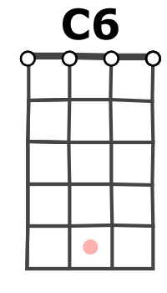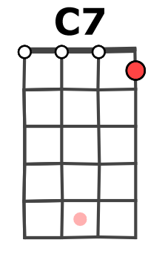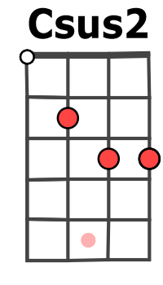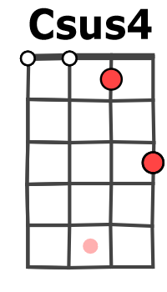

C / C6 C7 / C Csus2 / C Csus4 / C
(= G.0.0 / 2.2 .. 3.3 / 5.5 …. 7.7…. / 9.9.…10.10 / 12.12 )

F Bbmaj7 (G2, G0, E1)x2 F Bbmaj7 (G2, G0, E1)x2
Love is in the air, Love is in the air.
Am Dm / Db C C C C
ooooh mmmhmmmhmmh

F F Bbmaj7 Bbmaj7
Oh, love is in the air, in the rising of the sun
F F Bbmaj7 Bbmaj7
Love is in the air, when the day is nearly done.
C Bb C Dm
But I don't know if you're an illusion, Don't know if I see the truth,
Db F D7 Gm7 / C
But there's something that I must believe in, and you're there when I reach out for you.

Couplet 1 dernier accord Gm7 / Db (à la place de Gm7 / C7)

C / C6 C7 / C Csus2 / C Csus4 / C

F Bbmaj7 (G2, G0, E1)x2 F Bbmaj7 (G2, G0, E1)x2
Love is in the air, Love is in the air.
X 2
Am Dm / Db C / C6 C7 / C Csus2 / C Csus4 / C (i)
ooooh mmmhmmmhmmh
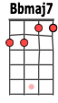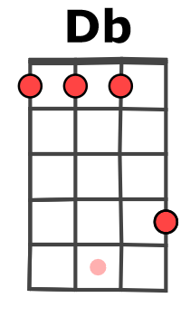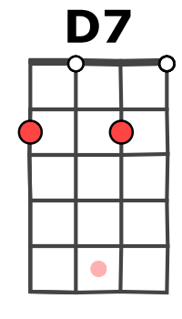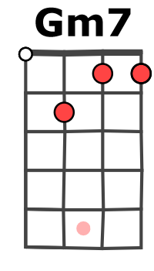
M-A V2

