Enola Gay – Orchestral Manoeuvre in the Dark (1980) BPM 143
C Am
1. Enola Gay, you should have stayed at home yesterday,
F G
uh-huh, this can't describe the feelin' and the way you lied.
C Am
These games you play, they're gonna end in all the tears someday,
F G
uh-huh, Enola Gay, it shouldn't ever have to end this way

+ C - Am - F – G thème

C Am F
2. It's eight fifteen, that's the time that it's always been, we got your message on the radio,
G
condition's normal and you're comin' home. + C - Am - F - G thème x 2


C Am
3. Enola Gay, is mother proud of little boy today ?
F G
Uh-huh, this kiss you give, it's never ever gonna fade away !

+ C - Am - F - G thème x 2

C Am
4. Enola Gay, it shouldn't ever have to end this way,
F G
uh-huh, Enola Gay, it should have faded our dreams away.
C Am F
It's eight fifteen, that's the time that it's always been, we got your message on the radio,
G
condition's normal and you're comin' home.
C Am
Enola Gay, is mother proud of little boy today ?
F G
Uh-huh, this kiss you give, it's never ever gonna fade away !

+ C
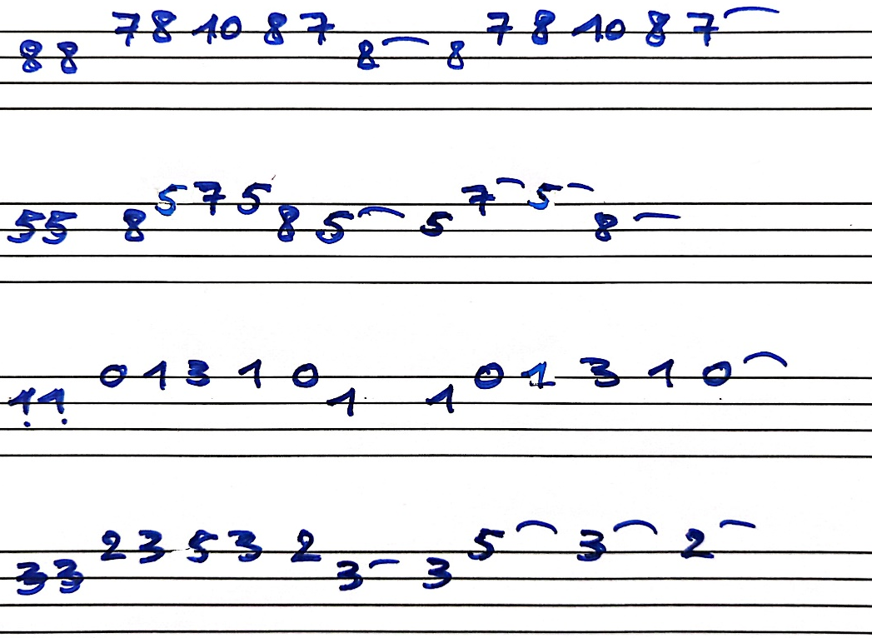
Thème :
TOP5

