
I will survive (Gloria Gaynor, 1978) 234 BPM tona originale

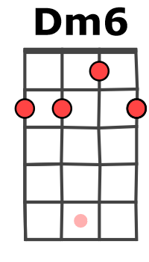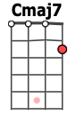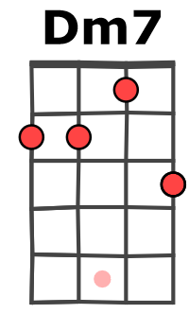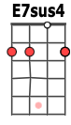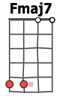
Bx ou hx : ne pas laisser résonner

Am… Dm7… G7… Cmaj7…
At first I was afraid, I was petrified, kept thinking I could never live without you by my side.
Fmaj7… Dm6…
But then I spent so many nights, thinking how you did me wrong,
E7sus4… E7…
And I grew strong and I learned how to get along.

Am Dm7
1 & 2 & 3 & 4 & 5 & 6 & 7 & 8 &
B B h B B B

But so you're back, from outer space,
G7 Cmaj7
I just walked in, to find you here, with that sad look upon your face.
Fmaj7 Dm6
I should have changed that stupid lock, I should have made you leave your key,
E7sus4 E7
If I had known for just one second, you'd be back to bother me.

Am Dm7
Am Dm7
Oh no, not I ; I will survive,
G7
Oh, as long as I know how to love,
Cmaj7
I know I'll stay alive.
Fmaj7
I've got all my life to live,
Dm6
And I've got all my love to give,
E7sus4 E7
And I'll survive, I will survive, hey hey

Go on now, go, walk out the door
P
R
É R
E
F
R
A
I
N
G7
R
E
F
R
A
I
N
Just turn around now,
Cmaj7
'Cos you're not welcome any more.
Fmaj7
Weren't you the one who tried
Dm6
To hurt (2break) me with goodbye ?
E7sus4
Did you think I'd crumble ;
E7
1 & 2 & 3 & 4 & 5 & 6 & 7 & 8 &
B Bx hx B B B

did you think I'd lay down and die ?

1 & 2 & 3 & 4 & 5 & 6 & 7 & 8 &
B Bx hx B b h B h B h

Am Dm7 G7 Cmaj7 Fmaj7 Dm6 E7sus4 E7

Am Dm7
3. It took all the strength I had not to fall apart.
P
R
É R
E
F
R
A
I
N
P
R
É R
E
F
R
A
I
N
4. And you see me ; somebody new,
R
E
F
R
A
I
N
R
E
F
R
A
I
N
G7 Cmaj7
3. Kept trying hard to mend the pieces of my broken heart.
4. I'm not that chained up little person, still in love with you.
Fmaj7 Dm6
3. And I spent oh, so many nights, just feeling sorry for myself,
4. And so you felt like dropping in and just expect me to be free,
E7sus4 E7
3. I used to cry, but now I hold my head up high.
4. Well, now I'm saving all my loving, for some-one who's loving me Ami

