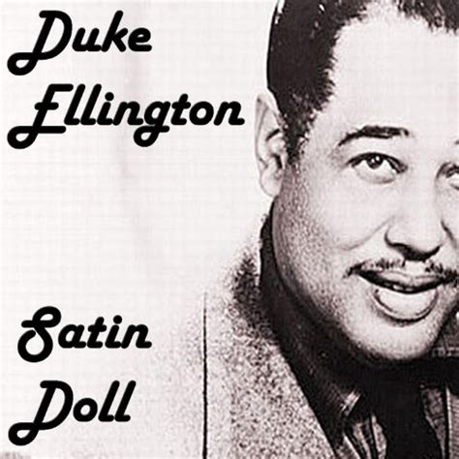
Satin Doll.
Duke Ellington / Bill Strayhom.
1953. 89 bpm.

Intro : Cm7 / F9 Cm7 / F9

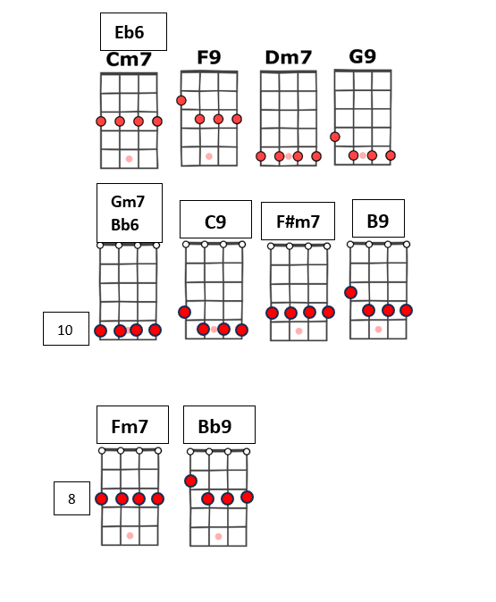
Cm7 / F9 Cm7 / F9
Cigarette holder which wigs me
Dm7 / G9 Dm7 / G9
over her shoulder, she digs me.
Gm7 / C9 F#m7/ B9 Bb6 Bb6
Out cattin' that satin doll

Cm7 / F9 Cm7 / F9
Baby, shall we go out skippin ?
Dm7 / G9 Dm7 / G9
Careful, amigo, you're flippin',
Gm7 / C9 F#m7 / B9 Bb6 Bb6
speaks Latin that satin doll

pont
Fm7 / Bb9
She's nobody's fool
Fm7 / Bb9 Eb6 Eb6
so I'm playing it cool as can be.
Gm7 / C9 Gm7 / C9 Cm7
I'll give it a whirl but I ain't for no girl catching me
F9↓ F9 (4 - 3 – 2 - 1)
swich-e- rooney.

Cm7 / F9 Cm7 / F9
QR code vers tuto

Telephone numbers well you know,
Dm7 / G9 Dm7 / G9
doing my rhumbas with uno
Gm7 / C9 F#m7/ B9 Bb6 Bb6 ↓ ↓↑↓
and that'n my satin doll
M. pour Virginie. V1

