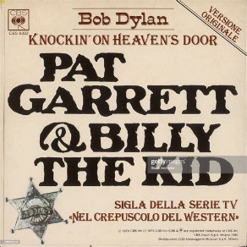
Knockin’ on heaven’s door
Bob Dylan. 70 bpm. 1973
G D Am Am
Momma take this badge off of me
G D C C
I can't use it anymore
G D Am Am
It's getting dark, too dark to see
G D C C
Feels like I'm knocking on heaven's door
Intro : G D Am Am G D C C x2

G D Am Am
Knock knock knocking on heaven's door
G D C C
Knock knock knocking on heaven's door
G D Am Am
Knock knock knocking on heaven's door
G D C C
Knock knock knocking on heaven's door

REFRAIN

G D Am Am
Momma put my guns in the ground
G D C C
I can't shoot them anymore
G D Am Am
That long black cloud is coming down
G D C C
I feel I'm knocking on heaven's door


REFRAIN x2
+ G…
G D
1. 2. 3. 4. 1. 2. 3. 4.
↓ . ↓ ↓↑ ↓ . ↓ ↓↑
Am Am idem avec C
1. 2. 3. 4. 1. 2. 3. 4.
↓ . ↓ ↓↑ . ↑ . ↑ ↓↑↓↑

M V1

