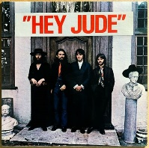
HEY JUDE. The Beatles. 1968. Remastered 2015. Tonalité : F. 74 bpm
B B B B
F C C7 F
Hey Jude don't make it bad take a sad song and make it better
Bb F C7 / C F / F…
Remember to let her into your heart then you can start to make it better

1. 2. 3. 4.
B BhB Bh
F C C7 F
Hey Jude don't be afraid you were made to go out and get her
Bb F C7 / C F / F7
The minute you let her under your skin then you begin to make it better

1. 2. 3. 4.
B BhB Bh

F7 Bb / Bbmaj7 Gm
And anytime you feel the pain hey Jude refrain
(Gm) C7 F / F7
Don't carry the world upon your shoulders
F7 Bb / Bbmaj7 Gm
For well you know that it's a fool who plays it cool
(Gm) C7 / C F(3 tps) /
by making his world a little colder
F(1 tps) F7↓↓ ↓ C7 ↓ C7… (C↓F↓C7↓↓)
nah nah nah nah nah nah nah nah

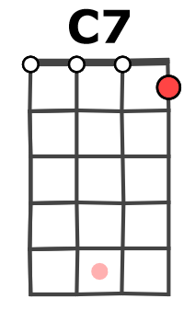
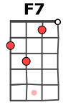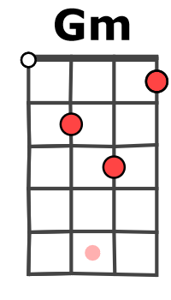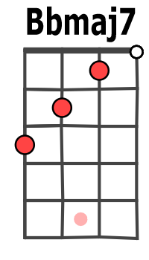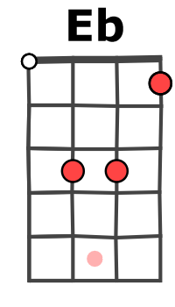
F C C7 F
Hey Jude don't let me down You have found her now go and get her
Bb F C7 / C F / F7
Remember to let her into you heart then you can start to make it better
1. 2. 3. 4.
B XhB Xh

M V3
1. 2. 3. 4.
B BhB Bh

1. 2. 3. 4.
B BhB Bh

F C C7 F
Hey Jude don't make it bad take a sad song and make it better
Bb F C7 / C F↓
Remember to let her into your skin then you begin to make it better

F ↓↑ ↓↑ ↓↑ F7↓↑ ↓↑ ↓…
better better better better better Oh!!!

F ↓↓↑ ↓ ↓ Eb ↓↑↓ ↓ ↓↑ ↓ Bb ↓↑ ↓ ↓ ↓↑ ↓↑ F ↓↓↑ ↓↓↑ Ad lib.
Nah Nah Nah nah Nah nah nah na, Hey Jude !
F7 Bb / Bbmaj7 Gm C F / F7
So let it out and let it in, hey Jude, begin you’re waiting for someone to perform with
F7 Bb / Bbmaj7 Gm
And don’t you know that it’s just you, hey Jude, you’ll do
(Gm) C7 / C F(3 tps) /
The movement you need is on your shoulders
F(1 tps) F7↓ ↓ C ↓ C7↓↓… (C↓ F↓ C7↓↓)
Nah nah nah nah nah nah nah nah yeah

