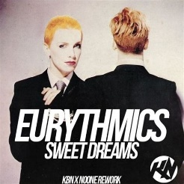
Sweet dreams. Eurythmics. 1983
125 bpm. (Tonalité originale : Cm)
1 . 2 . 3 . 4 .
B X h h X h
(F / E7* anticipé)
voix 1 voix 2
voix 1 et 2

Riff version Eurythmics :
A 0-0-7-0-8-0-7-0------3/5-----2/3
E ----------------------1-1-----0-0----

Riff puis riff + Intro : Am F / E7* x4

Am F / E7* Am F / E7*
1
Sweet dreams are made of this. Who am I to disagree?
Am F / E7* Am F / E7*
Travel the world and the seven seas. Everybody's looking for something

Am F / E7* Am F / E7*
2
Some of them want to use you Some of them want to get used by you
Am F / E7* Am F / E7*
Some of them want to abuse you. Some of them want to be abused
Break : F F / E7 Am Dm F E7 (8 par accords) ouh ouh….
Break : F F / E7 Am Dm F E7
1
Am
Sweet dreams

Am D
Hold your head up (movin'on) Keep your head up (movin'on)
BH XH BH XH
Am D
Hold your head up (movin'on) Keep your head up (movin'on)

Am D (BH XH / )
Hold your head up (movin'on) Keep your head up

Instru : Am F / E7* x4 + riff

Am F / E7* Am F / E7*
2
Some of them want to use you Some of them want to get used by you
Am F / E7* Am F / E7*
Some of them want to abuse you. Some of them want to be abused

Break : F F / E7 Am Dm F E7 (8 par accords)

Reprise Sweet dreams…

1
Reprise A cappellla + Sweet dreams…

Reprise Sweet dreams… x2 (2e fois en decrescendo) + Am…
M. V4
Riff version Marylin Manson :
A 0---0-0-3-3-0-0---------0------------
E -------------------- -1—1-----0-0-3-5

