
Hey, Soul Sister (Train, 2009) 97 BPM tonalite originale
1er E5 (4477) (1 & 2 & 3 & 4 &) x 2
x . X . x . X . x (b B h b h B h) x 2
1 & 2 & 3 & 4 & x 2
b B h b h B h x 2

E5 (4477) B C#m A
Hey, hey Hey, hey, hey, hey Hey, hey, hey, hey
E B C#m A
Your lipstick stains… on the front lobe of my left side brains
E B C#m A / B
I knew I wouldn't forget you and so I went and let you blow my mind
E B C#m A
Your sweet moonbeam… the smell of you in every single dream I dream
E B C#m A / B
I knew when we collid-ed, you're the one I had decided who's one of my kind

A B / E A B / E
Hey, soul sister, ain't that Mr. Mister on the radio, stereo, the way you move ain't fair you know
A B / E A B / Bi
REFRAIN
Hey, soul sister, I don't wanna miss a single thing you do……….... tonight

E5 B C#m A
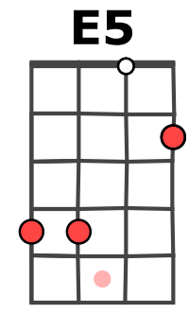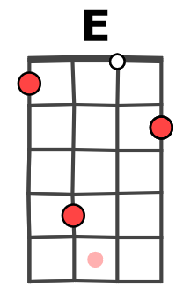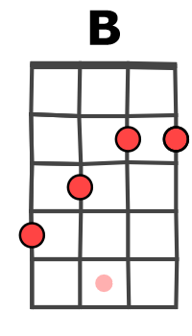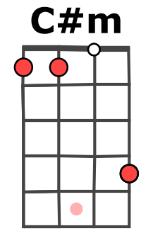
Hey, hey Hey, hey, hey, hey Hey, hey, hey, hey
E B C#m A
Just in time… I'm so glad you have a one track mind like me
E B C#m A / B
You gave my life direc-tion… a game show love connec-tion we can't deny…i…i…i
E B C#m A
I'm so obsessed… my heart is bound to beat right out of my untrimmed chest
E B C#m A / B
I believe in you, like a virgin you're madon-na and I'm always gonna wanna blow your mind

REFRAIN

E B C#m
The way you can cut a rug, watching you is the only drug I need, so gangsta, I'm so thug
A E
You're the only one I'm dreaming of you see, I can be myself now finally
B C#m A / B
In fact, there's nothing I can't be… I want the world to see you'll be with me

A B / E A B / E
Hey, soul sister, ain't that Mr. Mister on the radio, stereo, the way you move ain't fair you know
A B / E A B
Hey, soul sister, I don't wanna miss a single thing you do tonight
A B / E A B
Hey, soul sister, I don't wanna miss a single thing you do……… tonight

E5 B C#m A
Hey, hey Hey, hey, hey, hey Hey, hey, hey, hey tonight
E5 B C#m A / Ai E5…
M-A V0
Hey, hey Hey, hey, hey, hey Hey, hey, hey, hey tonight

