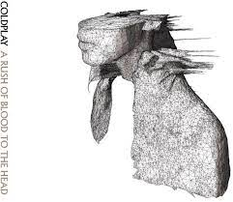
In my place (Coldplay, 2002) 145 BPM tona originale
Intro Couplet Riff
1 & 2 & 3 & 4 & / 5 & 6 & 7 & 8 &
B B h / h B B
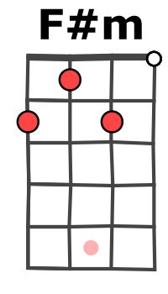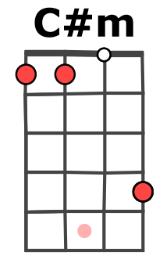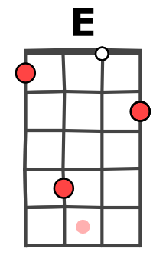

A / F#m C#m / E A / F#m
A..7…….7…………..4…….4…....7…….7…….……..4…….4…...7…….7…………...4…….4.
E………………...7……..7………………………...7……...7………………………..7……...7…..
C……4……..4………………..…….…4……..4…………………….…..4……..4………………..

(A du couplet)
A……….
E...5……
C……….

C#m / E
A..7…….7…….…….…..4…….4.
E……….…..7Ê9…..7……..7…..
C……4……..…………………….

INTRO : l’ensemble du riff x 2 puis

A / F#m C#m / E A / F#m C#m / E
In my place, in my place were lines that I couldn't change, I was lost, oh yeah
A / F#m C#m / E A / F#m C#m / E
And I was lost and I was lost crossed lines I shouldn't have crossed, I was lost, oh yeah

D A / E D A / E
REFRAIN
(Yeah)… How long must you wait for it ? (Yeah)… How long must you pay
D A / E D E
for it ? (Yeah)… How long must you wait for it ?...... Oh, for it

A / F#m C#m / E A / F#m C#m / E (Riff)

A / F#m C#m / E A / F#m C#m / E
I was scared, I was scared, tired and under prepared but I'll wait for it
A / F#m C#m / E A / F#m C#m / E
And if you go, if you go and leave me down here on my own then I'll wait for you yeah
D et E Refrain
1 & 2 & 3 & 4 & 5 & 6 & 7 & 8 &
B B B h h B h B
A / E
1 & 2 & 3 & 4 & 5 & 6 & 7 & 8 &
B B / B B
REFRAIN

A / F#m C#m / E A / F#m C#m / E x 2 (Riff x2)

A / F#m C#m / E
Singing please, please, please, come back
A / F#m C#m / E A / F#m C#m / E
And sing to me, to me, oh me come on and sing it out and now, and now come on
A / F#m C#m / E
And sing it out, to me, oh me come back
A / F#m C#m / E
And sing (to me), in my place, in my place were lines
A / F#m C#m / E A…
That I couldn't change, I was lost, oh yeah Oh Yeah
M-A V0
Merci à ukulelelovers.com

