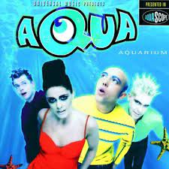
Barbie Girl Aqua 1997 130 BPM (tona originale en C#m)
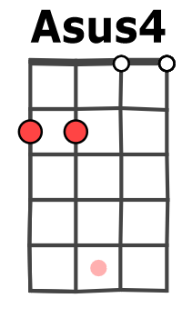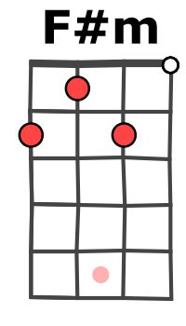

Rythme : B Bh hBh

Bm / Em A / D Bm / Em Asus4 / A
Hiya, Barbie Hi, Ken You want to go for a ride ? Sure, Ken Jump in

REFRAIN
Bm / Em A / D Bm / Em Asus4 / A
I'm a Barbie girl, in the Barbie world, life in plastic, it's fantastic
Bm / Em A / D Bm / Em Asus4 / A
You can brush my hair, undress me everywhere, Imagination, life is your creation

NC
Come on, Barbie, let's go party REFRAIN

Bm Bm Em A
I'm a blond bimbo girl in a fan-tasy world, dress me up, make it tight,
Bm Bm Em A
I'm your dol-ly You're my doll, rock'n'roll, feel the gla-mour in pink, kiss me here,
Bm
Touch me there, hanky pan-ky

Bm / Em A / D Bm / Em Asus4 / A
You can touch, you can play if you say, "I'm always yours" (ooh, oh)

G / A F#m / Bm
REFRAIN Come on, Barbie, let's go party (ah ah ah yeah)
Come on, Barbie, let's go party (ooh oh, ooh oh)
x 2
Bm Bm Em A
Make me walk, make me talk, do whate-ver you please, I can act like a star
Bm Bm Em A
I can beg on my knees, come jump in, bimbo friend, let us do it again, it the town,
Bm
fool around, let's go par-ty

Bm / Em A / D Bm / Em Asus4 / A
You can touch, you can play if you say, "I'm always yours" (ooh, oh)
x 2

G / A F#m / Bm
Come on, Barbie, let's go party (ah ah ah yeah)
Come on, Barbie, let's go party (ooh oh, ooh oh)
x 2

G / A F#m / Bm
REFRAIN x 2 Come on, Barbie, let's go party (ah ah ah yeah)
Come on, Barbie, let's go party (ooh oh, ooh oh)
x 2
G / A F#m / Bm G / A F#m / Bm
Oh, I'm having so much fun Well, Barbie, we're just getting started Oh, I love you, Ken !
M-A V1

