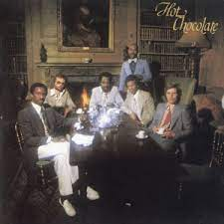
You sexy thing
1 & 2 & 3 & 4 & 5 & 6 & 7 & 8 &
B X B X
B X h h B X h B h
(Hot Chocolate, 1975) 106 BPM

F Bb F Bb x 2
F Bb F Bb
I believe in miracles, where you from, you sexy thing ? Sexy thing you
where you from, you sexy thing ?
REFRAIN
F Bb F Bb
I believe in miracles, since you came along, you sexy thing ?
you sexy thing ?

F Bb F Bb (Riff)
F Bb F Bb
Where did you come from, ba – by ? How did you know I needed you?
Bb C Bb C
How did you know I needed you so badly ? How did you know I'd give my heart gladly ?

Am Gm Am Am / C
Yesterday, I was one of the lonely people, now you're lying close to me, ma-kin' love to me

REFRAIN F Bb F Bb (Riff)
F Bb F Bb
Where did you come from, an – gel ? How did you know I'd be the one ?
Bb C Bb C
Did you know you're everything I've prayed for ? Did you know every night and day for ?

Am Gm Am Am / C
Ev-eryday, needing love and satisfaction, now you're lying next to me, givin' it to me

REFRAIN F Bb F Bb
Kiss me, you sexy thing, touch me baby, you sexy thing,
you sexy thing, you sexy thing,
F Bb F Bb
I love the way you touch me darlin', you sexy thing oh, it's ecstasy, you sexy thing,
Am Gm Am Am / C
Yesterday, I was one of the lonely people, now you're lying close to me, givin' it to me

REFRAIN F (Riff) Bb F (Riff) Bb
Touch me Kiss me darlin’
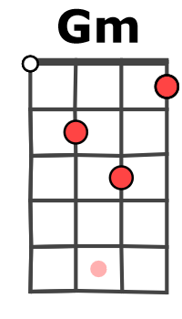
I love the way you hold me baby, oh, it's ecstasy, Ah,
it's ecstasy, sexy thing Kiss me ba-by …
F (Riff) Bb F (Riff) Bb
I love the way you kiss me darlin’ … Ah ah ah yeah …
I love the way you hold me … Keep on loving me darling …
F (Riff) Bb Fi
Keep on loving me baby Ah
F Bb riff uku ou basse
A ---------0-1-3-0-1---------------
E -1----------------------------------
M-A V1

