Who by fire.
Leonard Cohen. 1974

Intro :
Arpège : Am x2 F x2 E7 x2
Sur 4 temps : E7 alterner cordes C et E

Am G Am…
And who by fire
Am G Am…
Who by water
C G C…
Who in the sunshine
C G C…
Who in the night time
Am G Am…
Who by high ordeal
Am G Am…
Who by common trial
C G C…
Who in your merry merry month of May
C G C…
Who by very slow decay
Am x2 F x2 E(7)x2
And who shall I say is calling?
E7 alterner cordes C et E sur 2 temps

Am G Am…
And who in her lonely slip
Am G Am…
Who by barbiturate
C G C…
Who in these realms of love
C G C…
Who by something blunt
Am G Am…
Who by avalanche
Am G Am…
Who by powder
C G C…
Who for his greed
C G C…
Who for his hunger
Am x2 F x2 E x4
And who shall I say is calling?
E7 alterner cordes C et E sur 2 temps
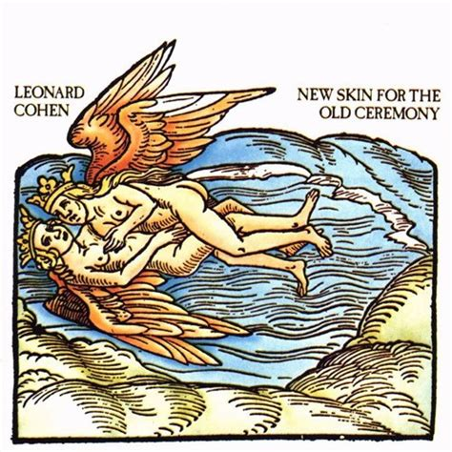

Am G Am…
And who by brave assent
Am G Am…
Who by accident
C G C…
Who in solitude
C G C…
Who in this mirror
Am G Am…
Who by his lady's command
Am G Am…
Who by his own hand
C G C…
Who in mortal chains
C G C…
Who in power
Am x2 F x2 E(7)x2
And who shall I say is calling?
E7 alterner cordes C et E sur 2 temps

E7 x2 (arpèges)
Am…

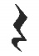
Strum :
B Bh B… (4 temps en tout)
A ------------X-
E -----X--------
C --X-----------
G --------X------
arpèges :

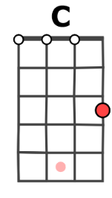
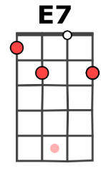
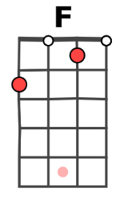
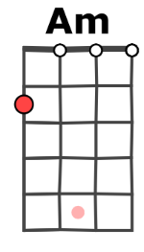

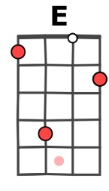
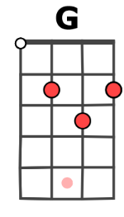

Mimi. V1

