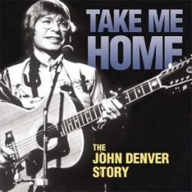
Take me home, country roads. 82 bpm
John Denver. 1971

intro : C Ternaire [B BH B BH] x2

C Am
Almost heaven, West Virginia,
G7 F / C
Ternaire
[B BH B BH] x2
Blue Ridge Mountains, Shenandoah River.
C Am
Life is old there, older than the trees,
G7 F / C
Younger than the mountains, growin' like a breeze.
Refrain
[B BH .H BH] x2
C G7 Am F
Country roads, take me home, To the place I belong
C G7 F C
West Virginia, mountain mamma, Take me home, country roads.

C Am
All my mem'ries, gather 'round her,
G7 F / C
Ternaire
[B BH B BH] x2
Miner's lady, stranger to blue water.
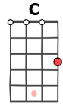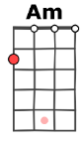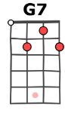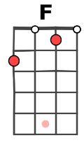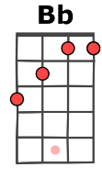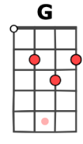
C Am
Dark and dusty, painted on the sky,
G7 F / C
Misty taste of moonshine, teardrops in my eye.
Refrain B BH .H BH x2

Am / G7 C
I hear her voice, in the mornin' hours she calls me,
F / C G7
Ternaire
[B BH B BH] x2
radio reminds me of my home far away.
Am / Bb
drivin' down the road,
F / C G
I get a feelin' that I should have been home yesterday,
G7 / G7
yesterday.

2x Refrain (B BH .H BH x2)
G7 C G7 C / C
Take me home, country roads, Take me home, country roads.

Mimi V4

