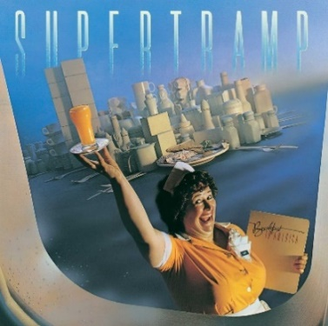
BREAKFAST IN AMERICA Supertramp 1979
Tonalité originale : Cm Bpm : 75

Intro : Gm x4
Gm / F Eb (Eb/F)
Take a look at my girlfriend She's the only one I got
Gm / F Eb
Not much of a girlfriend I never seem to get a lot
D / D7 Gm
Take a jumbo across the water Like to see America
D / D7 Cm… / F…
See the girls in California I'm ho-ping it's going to come true
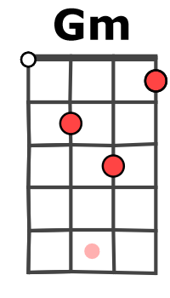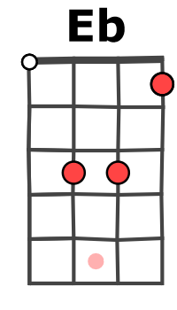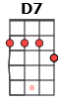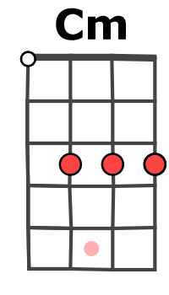
Cm… / F / F
But there's not a lot I can do

Gm / F Eb (Eb/F)
Could we have kippers for breakfast Mummy dear, Mummy dear
Gm / F Eb
They got to have 'em in Texas 'Cause everyone's a millionaire
D / D7 Gm
I'm a winner I'm a sinner Do you want my autograph
D / D7 Cm… / F…
I'm a loser what a joker I'm play-ing my jokes upon you
Cm… / F / F
While there's nothing better to do Heeey

D / D7 Gm
Ba ba da dum ba ba dum dao da da da dum
D / D7 Gm Eb… Cm… / F… / F…
Ba ba da dum ba ba dum dao da da da dum na na na na na na na na

Gm / F Eb (Eb/F)
Don't you look at my girlfriend (girlfriend) She's the only one I got
Gm / F Eb
Not much of a girlfriend (girlfriend) I never seem to get a lot
Rythme couplet : (x2)
A|------X-----X---
E|------X-----X---
C|---X-----X------
(What's she got ? Not a lot)
D / D7 Gm
Take a jumbo across the water Like to see America
D / D7 Cm… / F…
Rythme refrain :
B B B BhB B B Bh
See the girls in California I'm ho-ping it's going to come true
Cm… / F / F
But there's not a lot I can do

D / D7 Gm (x2)
Ba ba da dum ba ba dum dao da da da dum
D Gm (x2) Eb… Cm… / F…
Hey u-um, hey u-um, hey u-um, hey u-um na na na na na na na na
G / V2

