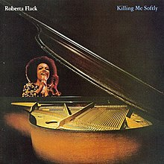
Killing me softly with his song (Roberta Flack, 1973) 122 BPM (-1/2 ton)
R
E
F
R
A
I
N
Em… (Am) (D7) (G)
Strumming my pain with his fin-gers….. Singing my life with his words


(Em) (A7) (D7) (C)
Killing me soft-ly with his song… Killing me soft-ly with his song
(G) (CM7) (F) (F) (E7) (E7)
Telling my whole life… with his words… Killing me soft-ly With his song

Am D7 G C
I heard he sang a good song I heard he had a style
Am D7 Em Em
1 & 2 & 3 & 4
B X h X
And so I came to see him and listen for a while
Am D7 G B7
And there he was this young boy A stranger to my eyes
REFRAIN
1 & 2 & 3 & 4
B X h h B

Am D7 G C
I felt all flushed with fe-ver Embarrassed by the crowd
Am D7 Em Em
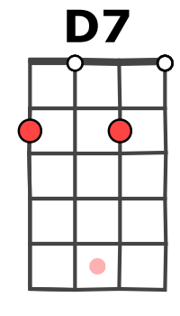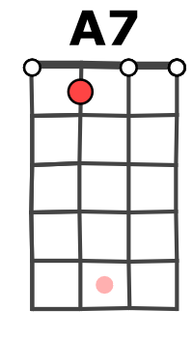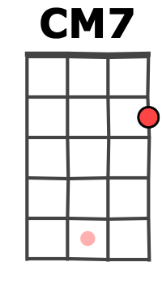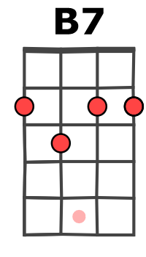

I felt he found my let-ters and read each one out loud
Am D7 G B7
I prayed that he would fi-nish But he just kept right on
REFRAIN

Am D7 G C
He sang as if he knew me In all my dark despair
Am D7 Em Em
And then he looked right through me as if I wasn't there
Am D7 G B7
And he just kept on singing Sin-ging clear and strong
REFRAIN

REFRAIN musical (Solo) (Oh Oh…)

Em Am D7 G
Strumming my pain with his fin-gers….. Singing my life with his words
Em A7 D7 C
Killing me soft-ly with his song… Killing me soft-ly with his song
G CM7 F F E7… (E7)
Telling my whole life… with his words… Killing me (soft-ly)

Em Am D7 G
He was strumming my pain Yeah, he was sin-ging my life
Em A7 D7 C
Killing me soft-ly with his song… Killing me soft-ly with his song
G CM7 F F E7…
Telling my whole life… with his words… Killing me soft-ly…… With his song…
Merci à Ukulele Lovers https://www.youtube.com/c/UkuleleLovers
M-A V1

