
A hard day’s night - The Beatles - 1964
Tonalité originale : G BPM : 134 Rythme : B-Bh-hB-
Intro : Gsus4…

C / F C* Bb C
It's been a hard day's night, and I've been working like a dog
C / F C* Bb C
Refrain
It's been a hard day's night, I should be sleeping like a log
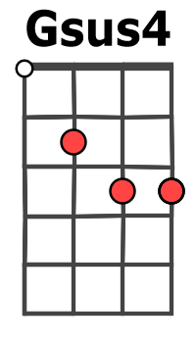
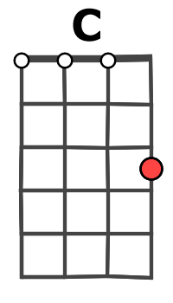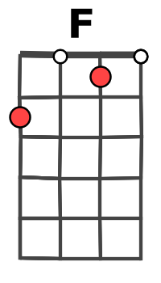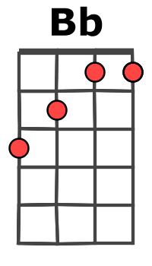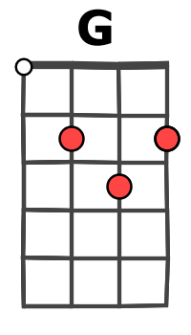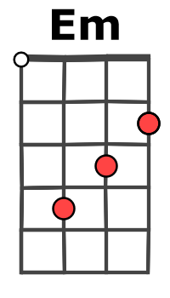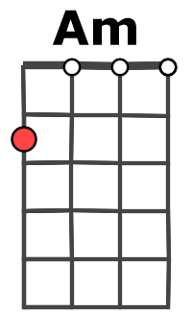
F G
But when I get home to you, I find the things that you do
C / F C*
Will make me feel al - right

C / F C* Bb C
You know I work all day, to get your money to buy you things
C / F C* Bb C
And it's worth it just to hear you say You're gonna give me everything
F G
So why on Earth should I moan ? ‘cause when I get you alone
C / F C*
You know I feel o - kay

Em Am Em Em
When I'm home, everything seems to be right
Rythme B-AH-HBH
C Am F G
When I'm home, feeling you holding me tight, tight, Yeah

Refrain

Instru :C / F C Bb C (X2)
|----------------|----------|---1---1---1---1------|----
|----------1-----|----------|1h3-1h3-1h3-1h3-3h1---|----
|0-----0-3---3-/7|----------|-------------------3h2|0---
|----------------|----------|----------------------|----

F G
So why on Earth should I moan ? ‘cause when I get you alone
C / F C
You know I'll be o - kay

Em Am Em Em
When I'm home, everything seems to be right
Rythme B-AH-HBH
C Am F G
When I'm home, feeling you holding me tight, tight, Yeah

Refrain

C / F C C / F Bb…
G+A / V3

You know feel al - right You know feel al - right

