
One of us (Joan Osborne, 1995) 86 BPM

F#m / D A / E F#m / D A / E x 4
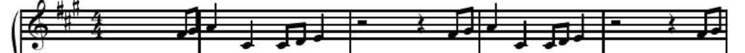
A…………………………………………...0…2…………………………0…2
E…………………2.4.5………………….0…..0...2.4.5……………….0…..0
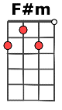
C………………………….1…1..2.4…..1……2………...1...1.2.4…..1……2
G……………………………………….2……..1…………………….2……..1

F#m / D
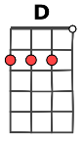
If God had a name…… what would it be ? And would you call it to his face ?
A / E F#m / D
B.B./ B.B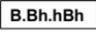.
If you were faced with Him in all His glory
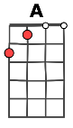
A / E F#m / D A / E
What would you ask if you had just one question ?
B.Bh.hBh
PREREFRAIN :
D E D E D E (8 ↓)
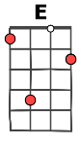
And yeah, yeah, God is great Yeah, yeah, God is good and yeah, yeah, yeah-yeah-yeah

REFRAIN :
F#m / D A / E F#m / D A / E
b.b.B.b
What if God was one of us ? Just a slob like one of us
F#m / D A / E F#m / D A / E ↓
Just a stranger on the bus… Tryin' to make his way home ?
B.B./ B.B.
F#m / D A / E F#m / D A / E
If God had a face……… what would it look like ? And would you want to see……. if, seeing meant
F#m / D A / D F#m / D A / E
That you would have to believe…… in things like heaven and in Jesus and the saints, and all the pro-phets ?
B.Bh.hBh
D E D E D E (8 ↓)
And yeah, yeah, God is great Yeah, yeah, God is good and yeah, yeah, yeah-yeah-yeah

F#m / D A / E F#m / D A / E
b.b.B.b
What if God was one of us ? Just a slob like one of us
F#m / D A / E F#m / D A / E
Just a stranger on the bus… Tryin' to make his way home ? Just tryin' to make his way
F#m / D A / E F#m / D A / E
Home…………... Back up to heaven all alone……………. Nobody callin'
F#m / D A / E D E
On the phone 'cept for the Pope maybe in Rome
B.B./ B.B.
B.Bh.hBh
D E D E ( F#m / D A / E ) x 4
B.Bh.hBh
D E D E D E (8 ↓)
And yeah, yeah, God is great Yeah, yeah, God is good and yeah, yeah, yeah-yeah-yeah
b.b.B.b
F#m / D A / E F#m / D A / E
What if God was one of us ? Just a slob like one of us
F#m / D A / E F#m / D A / E
Just a stranger on the bus… Tryin' to make his way home ? Just tryin' to make his way
F#m / D A / E F#m / D A / E F#m / D
Home………….... like a holy rolling stone……………….Back up to heaven all alone
A / E D D D D D
B.Bh.hBh
Just tryin' to make his way home…………............. Nobody callin' on the phone

D D…
'cept for the Pope maybe in Rome

V1

