LUCY IN THE SKY WITH DIAMONDS, BEATLES, 1967
Intro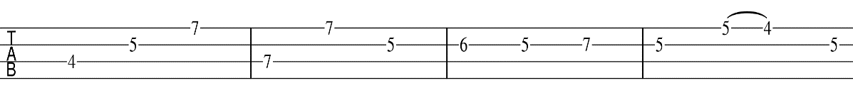  A / G F#m / Dm  Picture yourself in a boat on a river  A / G F#m / Dm Dm  with tangerine trees and marmalade skies  A / G - F#m / Dm  Somebody calls you, you answer quite slowly,  A / G F / F .  a girl with kaleidoscope eyes.  A / G F#m / Dm  Follow her down to a Bridge by a fountain  A / G F#m / Dm Dm  where rocking horse people eat marshmallow pies.  A / G F#m / Dm /  Everyone smiles as you drift past the flowers  A / G F#m / Dm. . .  that grow so incredibly high.  A / G F#m / Dm  Picture yourself on a train in a station  A / G F#m / Dm Dm  With plasticine porters with looking glass ties  A / G F#m / Dm  Suddenly someone is there at the turnstile  A / G F / F /. .  The girl with kaleidoscope eyes  ChorusX3: G C D  Lucy in the sky with diamonds,  D (hahaa) A (ah ah)  X3 Lucy in the sky with diamonds |   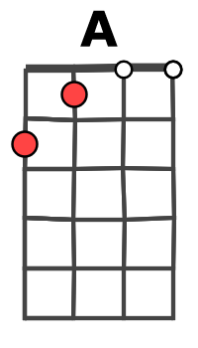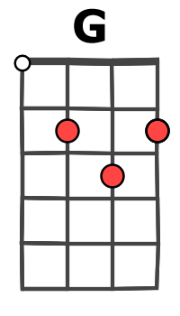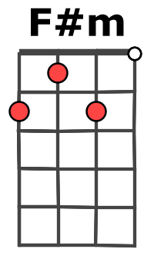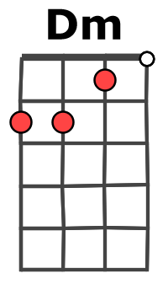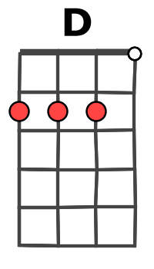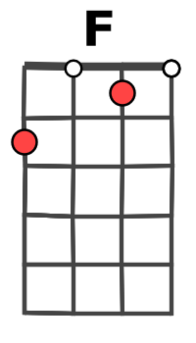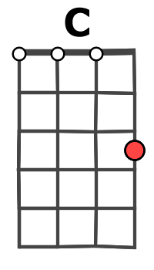  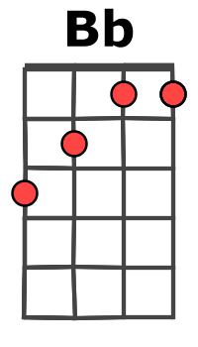  Couplet  B.B. sur chaque accord ou  B.Bbh  Refrain  G C D  B.Bbh B.Bbh B.B. hBhbB
  pont | Bb C  Cellophane flowers of yellow and green  Dm Bb  towering over your head  C G D ! . . .  Look for the girl with the sun in her eyes, and she’s gone
  Refrain | X3: G C D D  Lucy in the sky with diamonds X3 ahhh
  pont | Bb C  Newspaper taxis appear on the shore,  Dm Bb  waiting to take you away.  C G , D !  Climb in the back with your head in the clouds and you’re gone.
  Refrain | X3: G C D + D  Lucy in the sky with diamonds X3 ahhh

