HARVEST MOON - NEIL YOUNG - Paroles et musique : Neil Young 1992
4/4 ternaire – 112 bpm
Strum : d-du-du du-U-U-udu
Intro : D D6 Dmaj7 (4x) + (XXXXX)

Em7
Harmonique (XX XXX) Up…
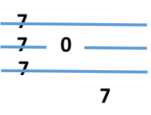
Come a little bit closer (XX XXX)
A
E
C
G
D D6 Dmaj7 (2x)
Hear what I have to say
(XX XXX)
Em7
Just like children sleepin' (XX XXX)
D D6 Dmaj7 (2x)
We could dream this night away

G
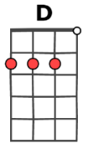
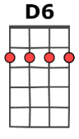
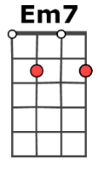
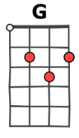
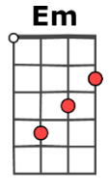
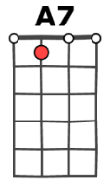
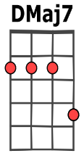
But there's a full moon risin'
D D6 Dmaj7 (2x)
Let's go dancin'in the light
G
We know where the music's playin'
D D6 Dmaj7 (2x)
Let's go out and feel the ni ght.

G A7
Because I'm still in love with you
Em
I want to see you dance ag ain
G A7
Because I'm st ill in love with you
D D6 Dmaj7 (4x)
On this harvest mo on.
(XX XXX)
Em7
When we were strangers (XX XXX)
D D6 Dmaj7 (2x)
I watched you from afar
(XX XXX)
Em7
When we were lovers (XX XXX)
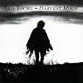
D D6 Dmaj7 (2x)
I loved you with all my hea rt
G
But now it's gettin'late
D D6 Dmaj7 (2x)
And the moon is climbin'high
G
I want to celebrate
D D6 Dmaj7 (2x)
See it shinin'in your eye

G A7

Because I'm still in love with you
Em
I want to see you dance a gain
G A7
Because I'm still in love with y ou
D D6 Dmaj7 (4x)
On this harvest mo on
Instrumental : mélodica + reprise à “Because…

