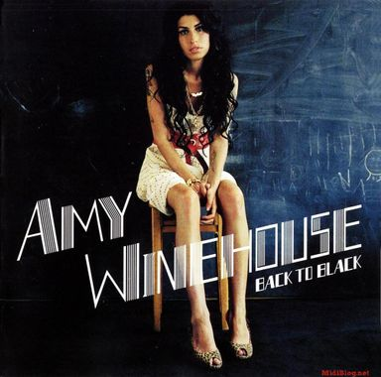
AMY WHINEHOUSE - Rehab 2006 (tonalité originale en C)
BPM : 72
Couplets : S comme Sylvie !
1et2et3et4et1et2et3et4et
B S h h X h B S h h X
Refrain : 1et2et3et4et1et2et3et4et
B X h h X h B h X h h X

D D
They tried to make me go to re-hab but I said, ‘No, no, no.’
D D
Yes, I’ve been black but when I come back you’ll know, know, know
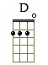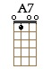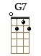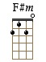
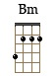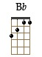
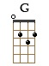
Refrain
A7 G7
I ain’t got the time and if my daddy thinks I’m fine
D / G7 D
He’s tried to make me go to re-hab but I won’t go, go, go

F#m Bm G Bb
I’d rather be at home with Ray I ain’t got seventy days
F#m Bm
‘Cause there’s nothing there’s nothing you can teach me
G Bb
That I can’t learn from Mr Hathaway
A7 A7 G7 G7
(I) didn’t get a lot in class But I know it don’t come in a shot glass

Refrain

F#m Bm G Bb
The man said, ‘Why (do) you think you’re here?’ I said, “I got no-o idea”
F#m Bm G Bb
I’m gonna, I’m gonna lose my ba-by So I always keep a bottle near.’
A7 A7 G7 G7
He said, “I just think you’re depressed.” This me “Yeah, baby, and the rest.”
D D
They tried to make me go to rehab but I said, ‘No, no, no.’
D D
Yes, I’ve been black but when I come back you’ll know, know, know

F#m Bm G Bb
I don’t ever wanna drink again I just, ooh, I just need a friend
F#m Bm G Bb
I’m not gonna spend ten weeks Have everyone think I‘m on the mend
A7 A7 G7 G7
It’s not just my pride It’s just ’til these tears have dried
Refrain D / G7 D (BXh hXh)
Dernière phrase : He’s tried to make me go to re-hab but I won’t go, go, go
G / V2 Top 5

