
Karma Chameleon (Culture Club, 1983) 92 BPM
1 et 2 et 3 et 4 et x 2
↓ ↓ ↑ ↑ ↓ x 2
En D (Tonalité originale Bb)

INTRO : D / A D X 2
COUPLET 1 : D / A D
Desert love in your eyes all the way
D / A D
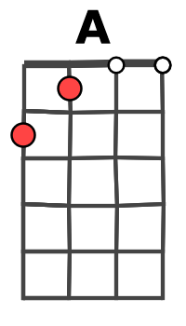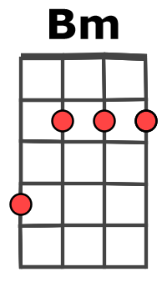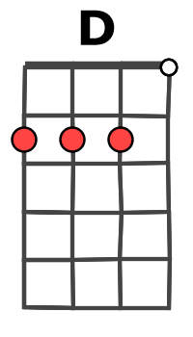
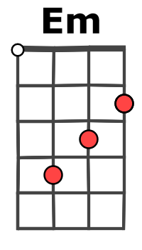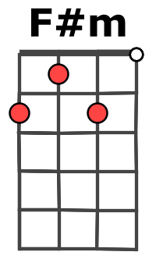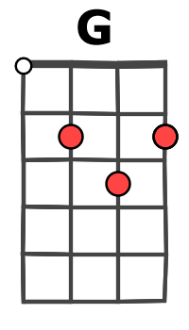
if I listen to your lie would you say
Prérefrain 1 : G A
I'm a man (a man) whithout conviction
G A
I'm a man (a man) who doesn't know
G A
How to sell (to sell) a contradiction
Em Bm / A (block)
You come and go …….. You come and go

REFRAIN : D / A Bm
Karma Karma Karma Karma Karma Chameleon
Em D / A
You come and go……… You come and go
D / A Bm
Loving would be easy if your colours were like my dream
Em D / A
Red, gold and green …….Red, gold and green

COUPLET 2 : D / A D
Didn't hear your wicked words every day
D / A D
And you used to be so sweet I heard you say
Prérefrain 2 : G A
That my love (my love) was an addiction
G A
When we cling (we cling) our love is strong
G A
When you go (you go) you're gone forever
Em Bm / A (block)
You string along …….You string along
REFRAIN

PONT : G F#m G Bm / Bm
Every day is like survi--val (survival), You're my lover (my lover) not my ri-val
G F#m G Bm / A
Every day is like survi--val (survival), You're my lover (my lover) not my ri---val

D / A D X 2 Prérefrain 1 REFRAIN x 2 D / A D / D ↓
M-A + A V4

